**Optimizing Employee Welfare Schemes Using Business Analytics: A Case Study on ONGC (Dehradun Tel Bhawan)**

**Summer Internship report**

**at ONGC**

Submitted in

Partial fulfillments of

Masters OF Business Administration

Program of

DBS Global University, Dehradun

BY

**Abhishek Singh Rana**

**0241MBA508**

**Under the Guidance of**

**Prof. Rajat Garg**

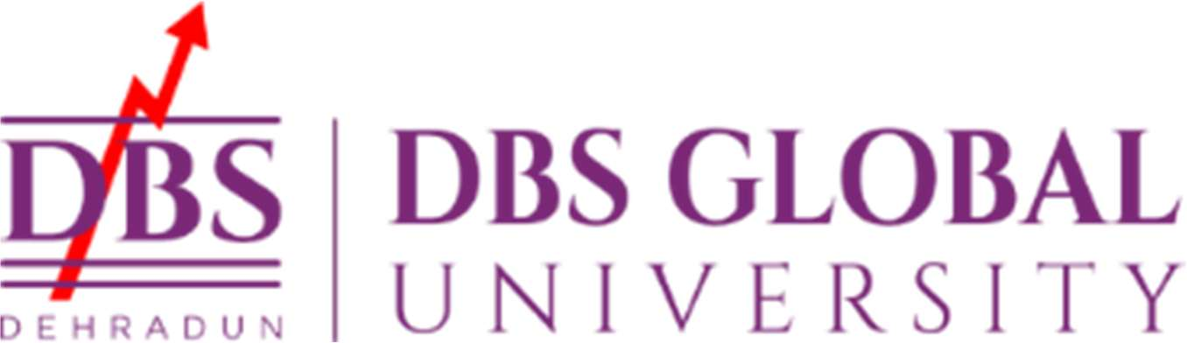

**LETTER OF TRANSMITTAL**

To

Professor Rajat Garg,

Doon Global University

Selaqui , Dehradun

Subject - Submission of . Internship Report

Sir / Madam ,

I am pleased to submit herewith my Summer Internship Report titled **“Optimizing Employee Welfare Schemes Using Business Analytics: A Case Study on ONGC (Dehradun Tel Bhawan)”,** which I have completed at **ONGC**, as part of the requirement for the successful completion of the **MBA** at Doon Global University.

This report is a comprehensive summary of the tasks, projects, and experiences I undertook during my internship from [16June 2025] to [14 August 2025]. It reflects the learning outcomes, challenges faced, and practical insights gained throughout the period.

I would like to express my sincere gratitude to you and the faculty for your continuous guidance and support. I am also thankful to my internship supervisor and colleagues at ONGC for providing a learning-rich environment and valuable exposure to real-world practices.

Yours sincerely

Abhishek Singh Rana

(0241MBA508)

**DECLARATION**

I declare that the Summer Internship Project report titled **“Optimizing Employee Welfare Schemes Using Business Analytics: A Case Study on ONGC (Dehradun Tel Bhawan)”** was prepared by me as part of my Master of Business Administration degree. I completed this project under the guidance of **Prof. Rajat Garg** . I also confirm that I haven't submitted this report for any other degree, diploma, fellowship, or similar credential atDBS Global University .

Place: Dehradun Abhishek Singh Rana

Date: 0241MBA508

Certificate from Company

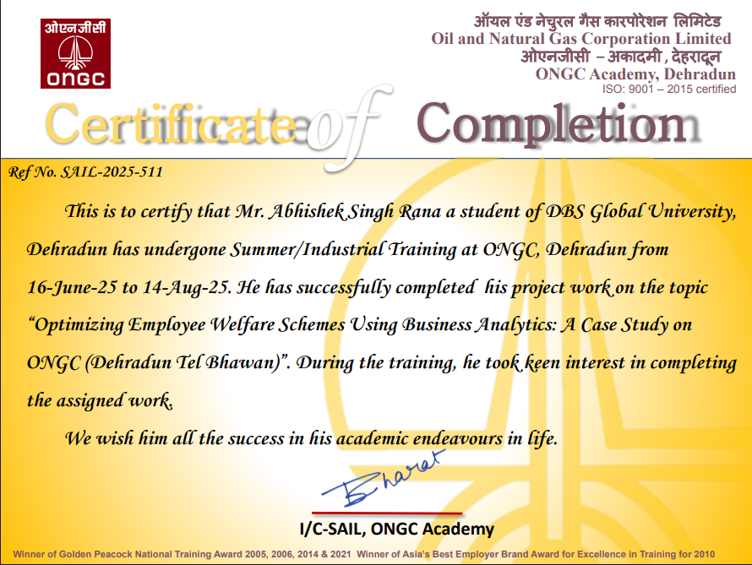

# ACKNOWLEDGEMENT

I want to sincerely thank **Prof. Rajat Garg** for all the guidance, helpful feedback, and ongoing support during this project. Preparing a project of this nature is an arduous task and i was fortunate enough to get support from a large numbers of persons to whom I shall always remain grateful.I take this opportunity to thank all the respondents for giving their precious time and relevant information and experience i require without which this project would have been a different story.I owe my regard and sincere gratitude to **Mr. Amit Minz** **(**General Manager**),** OIL AND NATURAL GAS CORPORATION LIMITED, Dehradun, for granting me permission to do summer training in such a prestigious company and for his valuable guidance and constant inspiration in steering this course of study towards successful completion. I sincerely and whole-heartedly thank to **Mrs. Shobha Negi of ONGC** for giving me value suggestions and advice throughout the execution of the project. This project would not have been concluded successfully within time without their support and help.

**(**Abhishek Singh Rana**)**

**0241MBA508**

**PREFACE**

As a part of the MBA curriculum with a specialization in Business Analytics, gaining practical exposure to real-world organizational data and systems is essential for understanding how analytical tools and insights can support strategic decision-making—especially in the Human Resource domain.

I consider myself privileged to have had the opportunity to undertake my summer internship at ONGC, Dehradun, specifically at ONGC Tel Bhawan. This training allowed me to gain valuable insights into the organization's and explore how Business Analytics can be leveraged to optimize HR functions.

ONGC, a leader in oil and natural gas exploration and production, is a data-driven and forward-looking organization that continuously strives to improve its internal systems and processes to enhance overall effectiveness. With a workforce of over 40,000 employees, managing human capital efficiently is critical. This necessitates a strategic blend of data analysis, technical understanding, and human insight.

In this report, I have attempted to analyze the **(Employee Welfare Schemes ) at ONGC** through the lens of Business Analytics, aiming to understand how data-driven evaluations can support HR decisions, boost employee performance, and align talent management with organizational goals.

**TABLE OF CONTENTS**

|  |  |
| --- | --- |
| **PARTICULARS** | **PAGE No.** |
| **Letter of transmittal** | **2** |
| **Declaration** | **3** |
| **Certificate** | **4** |
| **Executive Summary** | **9** |
|  | **(13-41)** |
| **PART1** |
| Introduction |
| About the organization | **13** |
| ONGC vision and mission | **14** |
| ONGC HR vision, mission and objectives | **15** |
| History of ONGC | **16** |
| Evolution | **22** |
| Future of ONGC | **25** |
| Integrated annual report | **33** |
| Organogram | **37** |
| Consolidated financial statements | **38** |
| Introduction to HRM | **41** |
|  | **(44-52)** |
| **CHAPTER 2** |
| Literature review |
| Plan of study | **44** |
| Study on welfare schemes by ONGC | **47** |
| Employee welfare measures | **52** |
|  | **(61-65)** |
| **CHAPTER 3** |
| Research Methodology |
| Research design | **64** |
|  | **(65-131)** |
| **CHAPTER 4** |
| Data analysis and interpretation |
|  | **65** |
| PART 1 : Employee survey and questionnaire |
| PART 2 : Analysis of survey response | **81** |
| PART 3 : Analysis with Power BI | **82-132** |
| PART 4: Interpretation of survey data | **82-132** |
| **CHAPTER 5** Recommendation | **(133-141)** |
|  | **(138-142)** |
| **CHAPTER 6** Conclusion |
| **Bibliography** | **(143-144)** |
| **Detailed Weekly Internship Summary** | **(145-147)** |
| **Plagiarism Report** | **149** |

**Executive Summary**

This project presents a data-driven analysis of the employee welfare schemes at Oil and Natural Gas Corporation (ONGC), Dehradun Tel Bhawan, to evaluate their effectiveness in enhancing employee retention and satisfaction. By analyzing survey responses from **400 employees** using business analytics tools like Power BI, the study uncovers a significant disconnect between ONGC's extensive welfare offerings and their actual impact on the modern workforce.The findings reveal a critical retention challenge, with **55% of employees having considered leaving the organization**. The welfare schemes currently serve as a retention lever for only

half of this at-risk group, influencing **50.75% to stay**. This limited effectiveness is directly linked to a mediocre perceived value; the schemes received an average **cost-benefit rating of just 2.53 out of 5** , with over half of the employees (51.5%) holding a neutral or negative view of their value.

**Key Findings**

* **High Attrition Risk:** A significant portion of the workforce is a flight risk, with the **Drilling and HR departments identified as hotspots**. The risk is most concentrated among experienced mid-career professionals.
* **Scheme Underperformance:** Foundational amenities like **canteen facilities are underutilized**, while schemes supporting long-term growth and family needs, such as **Employment Assistance and Schooling, are highly valued**.
* **Productivity Disconnect:** A low **Average Productivity Index of 1.38** suggests a possible disconnection between the welfare programs and daily employee output.
* **Demographic Mismatch:** The current "one-size-fits-all" approach is failing to meet the needs of a diverse workforce, which is predominantly composed of married, mid-career professionals in the 30-40 age bracket.

**Learnings from the Summer Internship Project**

**1. Strategic HR and Employee Welfare:**

* **Welfare Schemes as a Retention Tool:** A primary learning is that employee welfare schemes are a significant but not universally effective retention driver at ONGC. While they successfully influenced over half (50.75%) of at-risk employees to stay, a nearly equal number were not persuaded, indicating that welfare alone is not enough to guarantee loyalty.
* **Shifting Employee Priorities:** The project demonstrated that employees prioritize long-term growth and family-oriented benefits over basic amenities. Schemes like

**Employment Assistance** and **Schooling** saw the highest participation (94 employees each), while **Canteen Facilities** had the lowest (56 employees). This highlights a shift in what a modern workforce values.

* **One-Size-Fits-All is Obsolete:** The polarized feedback on welfare schemes, with nearly equal numbers rating them "Excellent" (98) and "Poor" (94), proves that a standardized approach is failing. The diverse needs of the workforce, especially given the large number of married employees and those in the 30-40 age bracket, necessitate a more customized and flexible benefits strategy.

**2. Application of Business Analytics in HR:**

* **Data-Driven Decision Making:** The internship was a practical application of using business analytics to transform raw survey data into actionable strategic insights. Tools like Power BI were instrumental in visualizing complex data to pinpoint specific problem areas, such as departmental attrition risks and underperforming schemes.
* **Identifying Hidden Trends:** Analytics helped uncover critical trends that were not immediately obvious. For example, it identified the
* **Drilling and HR departments** as high-risk zones for attrition and revealed that mid-career professionals are a key vulnerable cohort.
* **Connecting Metrics for Deeper Insights:** The project demonstrated the power of connecting different data points. The low employee cost-benefit perception score (2.53/5) was directly linked to why welfare schemes failed to influence nearly half the workforce, providing a clear "why" behind the retention challenge.

**3. Understanding Organizational Health:**

* **Widespread Attrition Risk:** A major learning was the scale of the retention challenge
* at ONGC. The fact that **55.25% of the surveyed workforce had considered leaving** indicates a systemic issue that goes beyond isolated incidents.
* **Productivity and Well-being Are Linked:** The analysis uncovered a very low **Average**
* **Productivity Index of 1.38**, suggesting a disconnect between employee welfare and daily output. This implies that for welfare schemes to be truly effective, they must contribute to holistic well-being that translates into better engagement and performance at work.
* **Demographics Drive Policy:** The study underscored how crucial demographic analysis is for effective HR policy. The needs of a workforce dominated by new hires (**0-4 years of service**) and mid-career professionals differ significantly, and policies must be adapted to remain relevant and effective.

**ABSTRACT**

The research work aims at identifying the facility management at ongc, Dehradun. During this research senior executives were interviewed and a survey was conducted through a questionnaire prepared to map the current status of facility management contract which was introduced about one year back. An effort was made to know the employees’ opinion about the facility management systems at ongc, Dehradun. On the basis of the research it is found that most of the employees feel that there some improvement required in the contract which is given to them. There is no immediate action taken by the company after the complaints are lodged in. an attempt was also made to project the services provided to the employees and their satisfaction level by the contract. To know do employees, think that there should be some modification for improvement. It is recommended that quick action should be taken as the complaints are lodged and there should be separate contract for different premises.

**PART 1 INTRODUCTION**

**ABOUT THE ORGANIZATION**

ONGC, a Maharatna company, is India’s leading producer of crude oil and natural gas, accounting for approximately 71% of the country’s domestic output. Crude oil, extracted by ONGC, serves as the primary raw material for downstream companies such as IOC, BPCL, HPCL, and MRPL (with HPCL and MRPL being ONGC subsidiaries) to manufacture petroleum products like petrol, diesel, kerosene, naphtha, and liquefied petroleum gas (LPG).

ONGC Videsh Limited, a Miniratna Schedule “A” Central Public Sector Enterprise (CPSE) under the Ministry of Petroleum & Natural Gas, functions as ONGC’s wholly owned subsidiary and international arm. Its core operations involve exploring, developing, and producing oil and gas in overseas territories. ONGC Videsh holds Participating Interests in 35 oil and gas assets spread across 15 countries and contributes roughly 30.3% of India’s oil and 23.7% of its total oil and gas output. Based on reserves and production, ONGC Videsh ranks as the second-largest petroleum company in India, following its parent ONGC.

This largest energy company has vast pool of skilled and talented professionals – the most valuable asset for the company. ONGCians dedicate themselves for the excellent performance of the company. ONGC extends several welfare benefits to the employees and their families by way of comprehensive medical care, education, housing and social security. The present workforce of the Energy Maharatna comprises of around 27,000 dedicated professionals.

This public sector enterprise operates with 14 seismic crews, manages 262 onshore production installations, 268 offshore installations, 69 drilling (plus 37 hired) and 54 work-over rigs (plus 25 hired), owns and operates more than 25,500 kilometers of pipeline in India, including 4,500 kilometers of sub-sea pipelines

ONGC: VISION AND MISSION

VISION: To be a world class Oil and Gas company integrated in energy business with dominant Indian leadership and global presence.

### **MISSION:** World Class

1. Dedicated to excellence by leveraging competitive advantages in R&D and technology with involved people
2. Imbibe high standards of business ethics and organization values.
3. Abiding commitment to health, safety and environment to enrich the quality of community life.
4. Foster a culture of trust, openness and mutual concern to make working a stimulating and challenging experience for our people.
5. Strive for customer delight through quality products and services.

#### **Integrated in Energy Business**

1. Focus on domestic and international oil and gas exploration and production business and opportunities.
2. Provide value linkages in other sectors of energy business
3. Create growth opportunities and maximise shareholder value

#### **Dominant Indian Leadership**

1. Retain dominant position in Indian Petroleum sector and enhance India’s energy availability.

***Carbon neutrality***

1.Strive to reduce carbon di-oxide emission across its activities chain with the objective of achieving carbon neutrality

# **ONGC: HR VISION, MISSION AND OBJECTIVES**

HR VISION:

To attain organizational excellence by developing and inspiring the true potential of company’s human capital and providing opportunities for growth, well-being and enrichment.

HR MISSION:

To create a value and knowledge based organization by inculcating a culture of learning, innovation and team working and aligning business priorities with aspiration of employees leading to a development of an empowered, responsive and competent human capital

HR OBJECTIVES:

* To develop and sustain core values
* To develop business leaders for tomorrow
* To provide job contentment through empowerment, accountability and responsibility
* To build and upgrade competencies through virtual learning,opportunities for growth and providing challenges in the job
* To foster a climate of innovation, creativity and enthusiasm
* To enhance the quality of life of employees and their families
* To inculcate higher understanding of ‘Service’ to a greater cause

# 

# **HISTORY OF ONGC**

# **(1947-1960)**

Before India gained independence, oil production in the country was limited to two main companies: the Assam Oil Company in the North-East and the Attock Oil Company in the North- West of undivided India. At the time, most of India’s sedimentary basins were considered unsuitable for oil and gas development.

After independence, recognizing the critical role of oil and gas in industrial growth and national defense, the Indian government prioritized the hydrocarbon sector in its 1948 Industrial Policy Statement.

Up until 1955, oil and gas exploration in India was predominantly undertaken by private firms. The Assam Oil Company was actively producing oil from the Digboi field in Assam, discovered in 1889. Meanwhile, Oil India Ltd.—a joint venture equally owned by the Government of India and Burmah Oil Company—was developing the Naharkatiya and Moran oil fields, also in Assam. In West Bengal, exploration efforts were led by the Indo-Stanvac Petroleum project, a collaboration between the Indian government and the American firm Standard Vacuum Oil Company. However, much of the country’s extensive sedimentary regions and adjacent offshore areas remained largely unexplored during this period.

In 1955, the Government of India took a strategic decision to develop oil and natural gas resources across the country through the Public Sector. To implement this vision, the Oil and Natural Gas Directorate was established under the Ministry of Natural Resources and Scientific Research. This new body was initially staffed with geoscientists drawn from the Geological Survey of India.

To strengthen the initiative, a delegation led by Mr. K. D. Malviya, the then Minister of Natural Resources, visited several countries to study their oil industries and arrange training opportunities for Indian professionals in oil and gas exploration. In return, foreign experts from the USA, West Germany, Romania, and the former USSR came to India to share their technical expertise. Notably, Soviet specialists developed a comprehensive plan for conducting geological and geophysical

. Surveys, as well as drilling activities, to be executed during the Second Five Year Plan (1956–57 to 1960–61).

In April 1956, the Indian government introduced the Industrial Policy Resolution, which designated the mineral oil sector as a Schedule 'A' industry. This classification meant that its development would be entirely under the control and responsibility of the state.

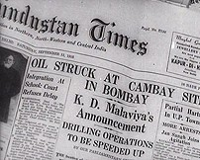

Soon after the establishment of the Oil and Natural Gas Directorate, it became clear that its limited financial and administrative authority hindered its effectiveness. To address this, in August 1956, the Directorate was upgraded to a Commission with greater powers, though it remained under government control

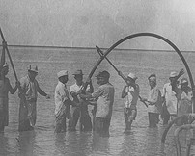Later, in October 1959, the Oil and Natural Gas Commission (ONGC) was formally made a statutory body through an Act of Parliament, further strengthening its authority. According to the Act, ONGC's primary responsibilities included planning, promoting, organizing, and implementing programs for the development of petroleum resources, as well as the production and sale of petroleum and its products. Additionally, ONGC was tasked with carrying out any other functions assigned by the Central Government. The Act also detailed the specific actions and measures ONGC was expected to undertake in order to fulfill its mandate.

## **1961-1990**

Since its establishment, ONGC has played a key role in expanding and strengthening India’s upstream oil and gas sector, turning it from a limited domain into a robust and wide-ranging industry. Its operations have spread across the country and into several international locations. Domestically, ONGC not only discovered additional reserves in Assam but also opened up a new oil-producing region in the Cambay basin in Gujarat. It further identified new petroliferous zones in the Assam-Arakan Fold Belt and the East Coast basins, both onshore and offshore.

In the early 1970s, ONGC ventured into offshore exploration and made a landmark discovery with the giant oil field known as Bombay High (now Mumbai High). This, along with later significant finds in the western offshore region, marked a major turning point in India’s oil industry. Altogether, more than 5 billion tonnes of hydrocarbons have been identified in the country. Perhaps ONGC’s most significant achievement lies in achieving self-sufficiency and developing world-class expertise in exploration and production (E&P) activities.

## **1990 onwards**

In July 1991, the Government of India introduced a liberalized economic policy aimed at deregulating and de-licensing key sectors, including petroleum. This policy also included partial disinvestment in Public Sector Undertakings (PSUs). As a result, ONGC was restructured into a limited company under the Companies Act, 1956, in February 1994.

Following this transformation from a statutory commission to Oil & Natural Gas Corporation Limited in 1993, the government sold 2% of its stake through competitive bidding. ONGC later increased its equity base by offering another 2% of shares to its employees.

In March 1999, ONGC formed strategic equity partnerships with Indian Oil Corporation (IOC), a major downstream company, and Gas Authority of India Limited (GAIL), the country’s main gas marketer. This cross-holding initiative laid the foundation for long-term collaboration across the entire energy value chain, both domestically and internationally.

In 2002–03, ONGC further expanded its presence by acquiring Mangalore Refinery and Petrochemicals Ltd. (MRPL) from the A V Birla Group, marking its entry into the downstream sector. The company also began its global foray through its international arm, ONGC Videsh Ltd. (OVL), making substantial investments in countries such as Vietnam, Sakhalin (Russia), Colombia, Venezuela, and Sudan. Its investment in Vietnam generated ONGC’s first overseas hydrocarbon revenue.

Recognized as a Maharatna PSU, ONGC stands as India’s largest producer of crude oil and natural gas, accounting for nearly 75% of the country’s domestic output.

The company’s commitment to energy exploration extends beyond achievements like deep-water drilling in the Krishna-Godavari Basin. Despite fluctuations in global oil prices, ONGC has consistently made strategic investments to boost offshore production and is now pushing into deeper offshore regions in pursuit of energy security. This relentless pursuit has earned ONGC a spot among Fortune’s “World’s Most Admired Companies.”

# **EVOLUTION: ONGC GROWTH STORY**

ONGC was established under the visionary leadership of Pandit Jawaharlal Nehru, who placed his trust in Shri Keshav Dev Malviya to lay its foundation. In 1955, Malviya initiated the Oil and Gas Division within the Geological Survey of India. Within a few months, this division evolved into the Oil and Natural Gas Directorate. On August 14, 1956, the Directorate was further elevated to form the Oil & Natural Gas Commission.

Highlighting the progress made by ONGC, Prime Minister Nehru remarked to Lord Mountbatten in 1959 that India had not only created its own system for oil exploration and development but had also established an efficient oil commission staffed by well-trained and capable young professionals doing commendable work.

In 1994, the Commission was restructured into a corporation, and in 1997, it earned the status of a Navratna company. Later, in 2010, ONGC was elevated to the prestigious Maharatna category by the Government of India.

Over its six-decade journey, ONGC has achieved numerous milestones in fulfilling India’s energy needs. Its story is one of determination, resilience, and dedication. Through its persistent efforts, ONGC has transformed once-untapped frontier regions into productive hydrocarbon reserves. From humble beginnings, it has grown into one of the world’s leading exploration and production (E&P) companies in terms of both reserves and output.

**The Company’s Evolution can be summarized as under:**

**1956** – Inception

**1958** – First Oil in Cambay

**1960** – Oil gas discovery in **Gujarat 1963** – Oil in Assam

**1965** – Concept of ONGC Videsh **Operations 1970** – First Offshore well

**1974** – Mumbai High discovered

**1976** – Bassein Gas field of Mumbai **High 1984** – GAIL formed out of ONGC

**1993** – ONGC a limited **company 1993** – Govt of India divest 2% share 1994 – 2% share to employees

**1999** – Equity swap ONGC, IOC, GAIL

**2003** – Acquired Mangalore Refineries Petrochemicals Ltd from **Birla Group 2003** – First equity Oil & gas from Sudan / Vietnam

**2004** – Govt of India divests 10%

**2006** – Diversification – ONGC Petro additives Ltd and ONGC Mangalore **Petro Ltd 2007** – ONGC Energy Center formed

**2010** – Coal Bed Methane **Production 2013** – Oil at Kazakhstan/Mozambique

**2014** – Top Energy Company of India; 5th in Asia, 21st globally: **Platts 2015** – ONGC Energy Center receives US Patent

**2016** – Forbes Global: ONGC 3rd largest in India

**2018** – 51.11% stake in Hindustan Petroleum Corporation Limited

**2019** – Invests Rs 83,000 crore in 25 projects; oil & gas gain over 180 MT

**2019** – Bengal Basin discovered

**2020** – ONGC bags 7 Blocks in Bid Round IV of **OALP 2021** – Bengal Basin dedicated to nation

**2022** – Vindhyan Basin discovered

With more than 60 years of Exploration ONGC had discovered 8 of the 9 Producing basins of India. These Oil Producing Basins are;

**1958** – Cambay, Gujarat .

**1963** -- Assam

**1967** – Rajasthan

**1974** – Mumbai Offshore

**1980** – Krishna Godavari Basin

**1985** -- Cauvery Basin

**2019** – Bengal Basin

**2022** – Vindhyan Basin

**FUTURE OF ONGC: THE ROAD AHEAD**

New discoveries and fast track development Equity oil from abroad

Downstream value additions & forward integration

Leveraging state-of-the art technology and global best practices Production from small and marginal fields

New sources of energy

This E&P company has taken structured initiatives to tap unconventional energy sources through unconventional gases like Coal Bed Methane (CBM), Underground Coal Gasification (UCG), Shale Gas and Gas Hydrates, or unconventional energy sources like wind, solar etc.

"ONGC Energy Centre Trust", a dedicated centre created by ONGC for holistic research in non- conventional energy sources, has taken up three projects viz., Thermo-chemical reactor for Hydrogen, Geo-bio-Reactors and Fuel Cells.

ONGC has already commissioned a 50 MW Wind Farm in Gujarat and plan is afoot to set up another 100 MW Wind Farm in Rajasthan.

ONGC has also set up 3 Solar Thermal Engines at Solar Energy Centre, Ministry of New and Renewable Energy (MNRE) campus at Gurgaon.

Energy strategy ⁀

2x Oil & Gas Production

3x Revenue distributed across E&P, refining & Marketing and other business 4x PAT with 10% contribution from non-Oil & Gas business

5-6x Market Capitalization current levels

**INTEGRATED ANNUAL REPORT :**

**Management Discussion and Analysis Report**

**Human Resource Development**

**ONGC considers its workforce to be its most valuable asset.** The company is dedicated to continually enhancing its human resource practices to ensure they remain industry-leading. ONGC’s growth and value generation are deeply rooted in the strength and commitment of its employees. As of March 31, 2024, the company employed 25,847 individuals.

With an upcoming generational shift in its workforce, ONGC places significant emphasis on strategic workforce planning and talent acquisition. A key objective is to shape the younger generation into future leaders in the energy sector. The company believes that sustained investment in employee development is crucial for maintaining engagement and driving performance.

To ensure a steady supply of capable leaders, ONGC is actively strengthening both technical and managerial capabilities within its workforce. It offers a wide range of leadership development programs, including the Leadership Development Program, Advanced Management Program, and Senior Management Program, specifically designed for mid- to senior-level executives.

Understanding the fast-evolving nature of the exploration and production (E&P) industry, ONGC extends its training initiatives by collaborating with top national and international institutions. These partnerships aim to keep its professionals equipped with the latest skills and knowledge.

As an equal opportunity employer, ONGC follows all constitutional and governmental norms to ensure fair and inclusive workplace practices. It promotes the development of all employees, regardless of caste, creed, race, gender, disability status, or background. The company provides industry-best support and opportunities, empowering employees to thrive professionally.

ONGC also continues to support sports development in India. It offers employment to athletes, awards scholarships to promising sports talent, and sponsors sports associations and federations. The company contributes to organizing sporting events and building sports infrastructure across the country.

In its continuous effort to enhance the work-life balance of its employees, Oil and Natural Gas Corporation (ONGC) has developed well-equipped residential townships across various operational sites. These townships are furnished with a range of recreational and fitness amenities, including gymnasiums, clubs, sports centers, and music rooms, all designed to promote a healthy and balanced lifestyle. Similar provisions have been extended to offshore living quarters, where employees are provided with facilities such as gyms, sports infrastructure, yoga spaces, and libraries. These amenities contribute significantly to the physical and mental well-being of employees working in challenging and remote environments.

To further support employee wellness, **Wellness Centers** have been established at various ONGC work centers. These centers offer medical consultations and professional counselling services not only for employees but also for their families. In addition to reactive healthcare, the Wellness Centers actively promote preventive health measures by raising awareness about lifestyle modifications and disease prevention through regular health talks and wellness sessions.

Such comprehensive well-being initiatives reflect ONGC’s commitment to nurturing a healthy workforce. The organization's efforts in the area of human resource development, particularly its holistic approach to employee welfare, have been widely acknowledged and commended within the industry.

**ONGC’S VISION AND MISSION FOR ITS EMPLOYEES**

The vision of Oil and Natural Gas Corporation (ONGC) is centered on the development and cultivation of world-class human capital capable of leading the energy sector. The organization's mission is structured around four key pillars: the creation of an exceptional and globally competitive work environment, a strong integration within the energy value chain, establishing a position of dominant leadership within the Indian energy landscape, and a steadfast commitment to achieving carbon neutrality.

Training and Development Initiatives

During the reporting year, Oil and Natural Gas Corporation (ONGC) demonstrated a strong commitment to employee development by allocating substantial resources towards training programs. On average, the company invested ₹1.92 lakh per employee for various developmental initiatives. Each employee received an average of 21.8 hours of skill-oriented training, aimed at enhancing their technical and professional capabilities.

In addition to technical competencies, the training programs also addressed critical areas such as anti-corruption practices, human rights awareness, and health and safety protocols. These efforts reflect ONGC’s emphasis on promoting an organizational culture rooted in ethical behavior, social responsibility, and employee well-being.

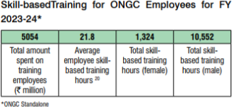

**TRAINING AND DEVELOPMENT**

ONGC fosters a vibrant and inclusive workplace culture grounded in core values such as integrity, a sense of belonging, collaboration, accountability, and innovation. The company’s employee- centric approach places significant emphasis on continuous learning and development as a key driver of professional growth.

At the heart of this initiative is the ONGC Academy, formerly known as the Institute of Management Development (IMD), which holds ISO 9001 certification. The Academy, in conjunction with seven other specialised training institutes, plays a pivotal role in equipping the workforce with up-to-date skills and knowledge aligned with evolving global industry standards.

Functioning as ONGC’s primary centre for human resource development, the ONGC Academy is dedicated to enhancing employee competencies through structured training programs. It supports professional development while simultaneously leveraging the technical expertise of employees in hydrocarbon exploration and production. This dual-focus strategy enables ONGC to stay at the forefront of technological and operational excellence, while also contributing meaningfully to the broader energy industry through its advanced training and knowledge dissemination.

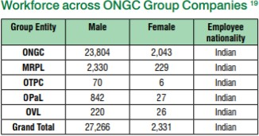

**EMPLOYEE SATISFACTION**

ONGC’s recognition as a “Great Place to Work” for four consecutive years stands as a testament to its unwavering commitment to employee development and well-being. This achievement reflects the organization’s belief that a motivated and supported workforce is essential to sustaining long-term success in the dynamic and competitive energy sector.

In its effort to ensure holistic employee satisfaction, ONGC offers a comprehensive range of benefits tailored to meet the diverse needs and aspirations of its employees. These well-structured provisions play a vital role in enhancing both professional fulfillment and personal well-being across all levels of the organization.

**GRIEVANCE REDRESSAL**

ONGC has implemented a robust framework to ensure the timely and fair resolution of employee concerns through multiple institutional mechanisms. These include the **Grievance Management System (GMS)**, **Safety Committees**, **Internal Complaints Committee**, and a comprehensive **Whistle-blower Policy**. Together, these systems reflect the organization's commitment to maintaining transparency, accountability, and a supportive workplace environment.

The **Grievance Management System** is applicable to all regular employees and addresses a wide range of issues, including compensation, leave entitlements, promotions, salary revisions, seniority, job assignments, and overall working conditions. The system functions through a structured **four- tiered process** that facilitates the systematic and equitable handling of employee grievances.

This well-defined grievance redressal mechanism plays a critical role in promoting employee trust, organizational transparency, and operational effectiveness, thereby contributing to a harmonious and productive work culture.

As part of its ongoing efforts to strengthen stakeholder engagement, ONGC has introduced a structured, web-based Grievance Redressal Portal. This initiative is in alignment with the Government of India’s Digital India mission, aiming to enhance transparency and efficiency in the citizen-government interface through the use of digital technologies.

The portal serves as a unified platform, enabling various stakeholders—including citizens, vendors, current employees, and former employees—to submit grievances related to any functional area of ONGC. By offering a single-window access via the corporate website, this digital mechanism empowers stakeholders to raise concerns in a transparent, accessible, and accountable manner.

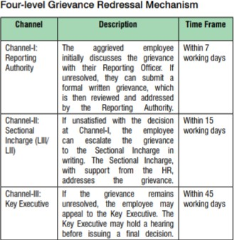

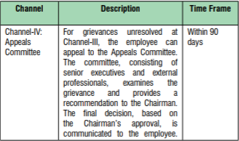

**EDUCATION AND SKILL TRAINING**

ONGC remains deeply committed to enhancing the quality of education and promoting skill development as a means of empowering communities. In alignment with this objective, the **Ankleshwar Asset** launched a targeted skill development program under the **Aspirational Districts Program (ADP)**, specifically aimed at improving employment prospects for youth in the **Narmada district**.

This initiative provided vocational training across multiple sectors, including **tourism, hospitality, healthcare, and tailoring**, thereby addressing diverse employment avenues. The program was implemented in collaboration with the **Human Development & Research Foundation** and the **Sanidhya Foundation**, ensuring both technical training and practical support. To further enable sustainable employment, participants were provided with essential resources such as **medical kits** and **sewing machines**, equipping them to immediately apply their newly acquired skills in real- world settings.

In Silchar, Assam, ONGC implemented a vocational training program targeting 100 unemployed youth from the Hailakandi District. The initiative aimed to equip participants with the necessary skills to secure meaningful employment within the telecommunications sector.

The training was comprehensive, covering both theoretical knowledge and practical hands-on experience, ensuring that beneficiaries developed a well-rounded understanding of the industry. This project was developed through a collaborative partnership involving ONGC, the Telecom Sector Skill Council, the Hailakandi District Administration, and various skill development organizations, demonstrating a multi-stakeholder approach to enhancing youth employability.

**FINANCIAL HIGHLIGHTS FY’24**

For the financial year 2024, the Company reported a **Profit After Tax (PAT)** of ₹405,260 million, reflecting an increase of ₹4,295 million (1.1%) compared to the restated PAT of ₹400,965 million in FY 2023. Despite this growth in profitability, the **Revenue from Operations** decreased by 11%, amounting to ₹1,384,021 million in FY 2024, down from ₹1,555,173 million in the previous year.

**Key Financial Highlights – Standalone Statements:**

* **Revenue from Operations:** ₹1,384,021 million
* **Profit After Tax:** ₹405,260 million
* **Contribution to Exchequer:** ₹650,569 million
* **Return on Capital Employed:** 30.60%
* **Debt-Equity Ratio:** 0.02:1
* **Earnings per Share:** ₹32.21
* **Book Value per Share:** ₹243

These figures underscore the Company’s strong financial position, efficient capital utilization, and consistent shareholder value creation despite the challenges in revenue generation.

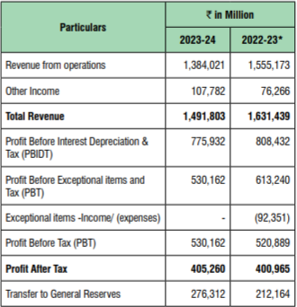

**HUMAN RESOURCE DEVELOPMENT**

As of March 31, 2024, ONGC had a total of 25,847 regular employees on its roster. Through strategic policy measures and effective HR practices, the company continues to empower its dedicated workforce to tackle emerging challenges and adapt to the evolving energy landscape.

**Capacity Building:**

In the fast-paced exploration and production (E&P) sector, it is essential for employees to possess the right knowledge, skills, and capabilities. ONGC's HR department has implemented some of the industry’s top training and development programs to address both present and future operational needs.

In FY 2023-24, ONGC provided training to 12,751 executives and 5,286 non-executives across various relevant fields.

**Apprenticeship Program:**

During the same fiscal year, ONGC engaged 1,441 apprentices across multiple trades— exceeding the minimum 2.5% of total workforce engagement required under the Apprenticeship Act, 1961.

**Employee Engagement:**

In FY 2023-24, ONGC carried out a wide range of employee engagement initiatives aimed at fostering collective growth, collaboration, innovation, and excellence. Key highlights include:

1. Over 60 ‘People Connect Programs were held across various ONGC work centers, focusing on themes such as:
   * Interactive sessions with senior executives and domain experts
   * Workshops on wellness and maintaining work-life balance
   * Sessions on POSH (Prevention of Sexual Harassment) and gender sensitization
2. The Annual ONGC Business Games were successfully organized to strengthen skills like strategic thinking, business insight, entrepreneurial learning, and decision-making in a simulated, competitive business environment. In FY’24, 239 teams comprising 946 executives participated.
3. Fun Team Games were also arranged for employees at E0 level and below as part of capacity building and engagement. These activities focused on enhancing results-oriented thinking, physical and mental agility, and teamwork, with over 480 employees taking part.
4. ONGC participated in the GOQii Corporate Challenge 2024 for the first time and achieved impressive results, securing second place overall on the Corporate Leaderboard. ONGC teams performed strongly, occupying the top two ranks, with three teams in the top five, five in the top

ten, and eight in the top fifteen. Additionally, 56 ONGC participants earned a perfect score of 1500, reflecting outstanding commitment throughout the competition.

**Work-Life Balance:**

ONGC is committed to enhancing the overall employee experience by providing well-equipped townships featuring amenities such as gyms, clubs, sports centers, and music rooms. Offshore accommodations also include facilities for fitness, sports, yoga, and libraries to support a balanced lifestyle.

The company actively supports various employee collectives and community groups—including the Officers’ Club, Women Development Forum, Employee Welfare Associations, and Resident Welfare Associations—across all its work centres. These groups regularly organize community events and activities that foster a sense of unity, collaboration, appreciation, and belonging among employees.

**Health and Wellbeing:**

To promote wellness, ONGC has established Wellness Centres at multiple work locations, offering consultation and counseling services for employees and their dependent family members. These centres focus on promoting healthy lifestyles and disease prevention through awareness campaigns and wellness sessions.

In line with its social responsibility, ONGC also plays a proactive role in addressing the healthcare needs of underprivileged communities in remote regions. Through its CSR initiatives, the company conducts multi-specialty medical camps where healthcare teams provide medical consultations, distribute medicines, and supply rehabilitation aids and spectacles to those in need.

**Diversity & Inclusion:**

ONGC is committed to being an equal opportunity employer, strictly following constitutional and government norms to ensure fair employment and growth opportunities for all individuals, regardless of caste, creed, race, gender, or disability. The company ensures adequate representation in line with official diversity guidelines.

**Women Development:**

As of March 31, 2024, women made up 7.9% of ONGC’s workforce. The company has been a leader in fostering an inclusive workplace environment that supports the professional advancement and leadership development of its women employees

**ORGANOGRAM OF ONGC**

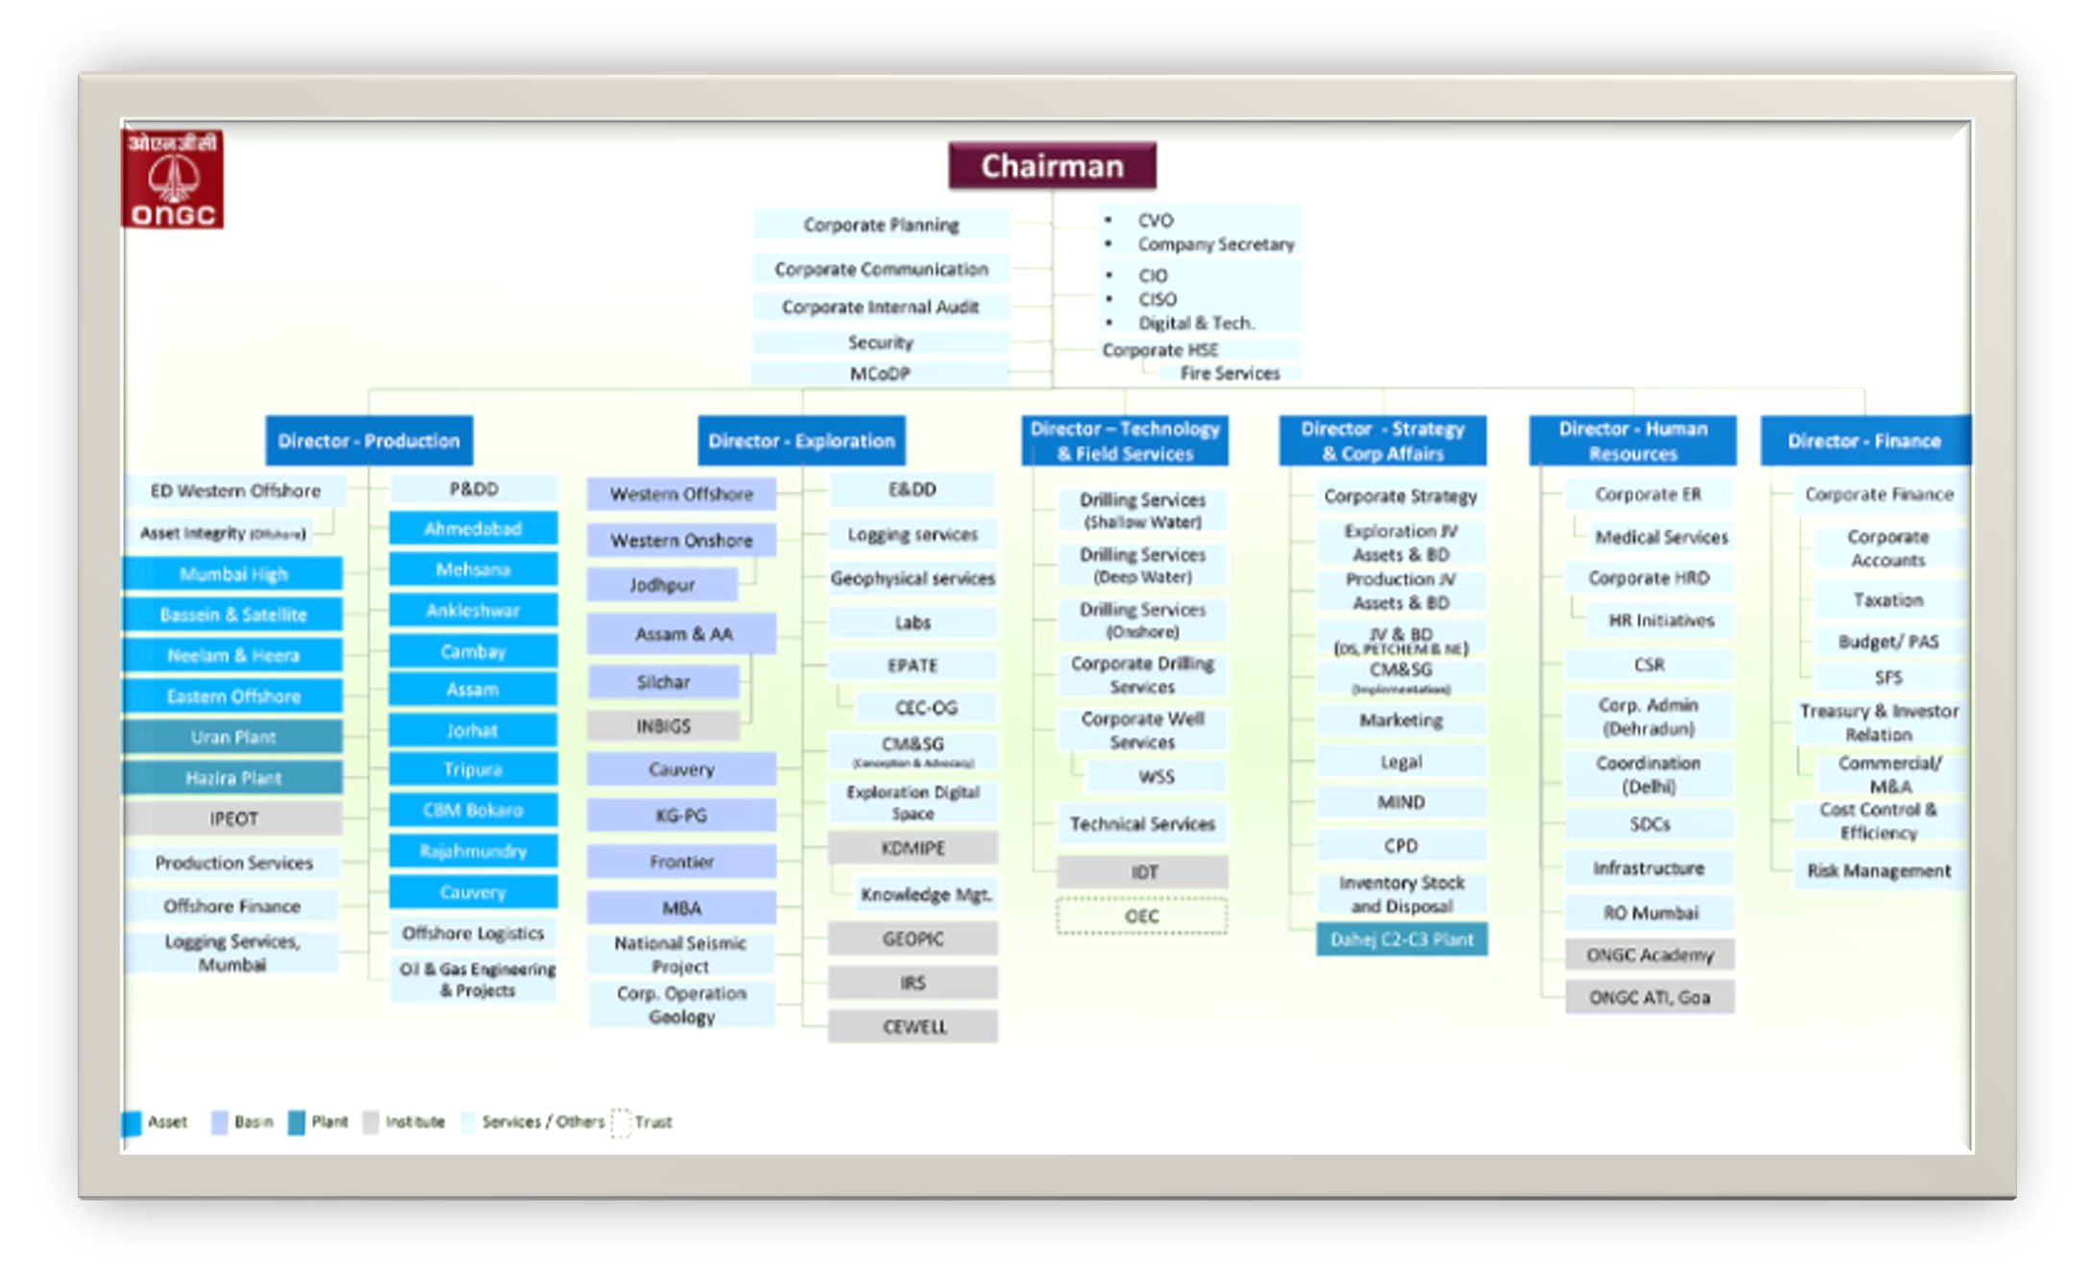

**CONSOLIDATED FINANCIAL STATEMENT**

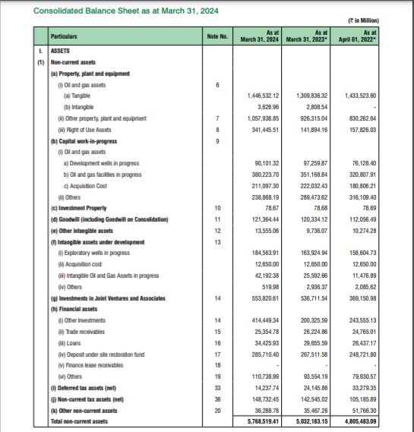

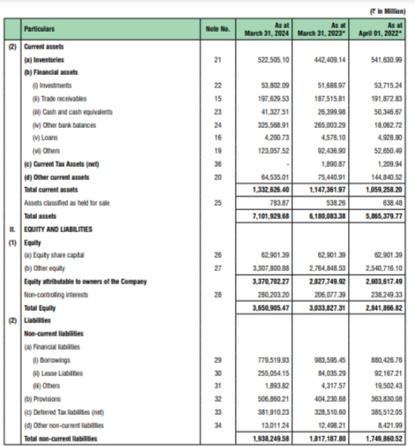

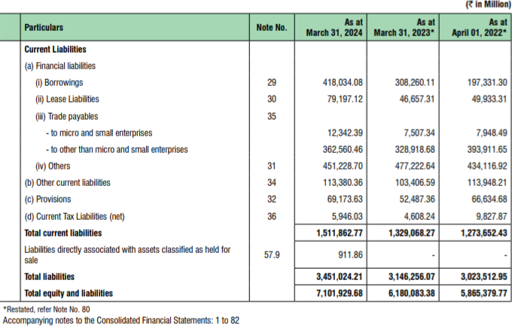

**INTRODUCTION TO HUMAN RESOURCE MANAGEMENT**

The human resources (HR) department plays a crucial role in managing core functions within an organization. These include ensuring compliance with labor laws, maintaining accurate records, overseeing recruitment and training, managing compensation, providing support for employee relations, and addressing performance-related issues. These responsibilities are vital for meeting the fundamental needs of both management and staff.

Traditionally, HR management involved selecting from a range of available HR practices and aligning those choices with the organization’s competitive strategy. Rather than choosing practices solely for their technical advantages, they should be selected based on how well they support the organization’s strategic goals. For example, whether a company competes through innovation, cost-efficiency, or superior service, its HR practices should promote the specific employee behaviors necessary to succeed in that strategy.

**Objective of Human resource management:**

The primary objective of human resource management (HRM) is to ensure that a skilled and prepared workforce is available to meet the organization’s needs. Beyond this, HRM also serves several other important purposes, generally categorized into four main areas: personal, organizational, functional, and societal.

**Personal Objective:**

To support employees in achieving their personal goals, as long as those goals contribute to the organization's success. It is important to maintain, support, and motivate individual employee aspirations to strengthen their commitment to the organization.

**Functional Objective:**

To ensure that the HR department operates at an optimal level, serving the organization's needs without overextending resources. If HR functions are more advanced than what the organization requires, it leads to inefficiency and wasted resources.

**Societal Objective:**

To act responsibly and ethically in addressing societal needs and challenges, while minimizing any negative effects these demands might have on the organization. HRM should utilize resources in a socially beneficial manner, contributing positively to society.

**Other Key Objectives Include:**

* Ensuring efficient use of human resources to support the organization’s goals.
* Building and maintaining a capable and motivated workforce to help achieve core organizational objectives.
* Contributing to the reduction of social issues like unemployment, underemployment, and economic inequality by creating opportunities for disadvantaged groups, including women and marginalized communities.
* Developing a competent and driven workforce while establishing a strong and effective organizational structure.
* Meeting individual and group needs through well-designed systems that foster growth alongside organizational development.
* Promoting collaboration among individuals and teams to support

organizational integration.

* Maintaining a productive organizational structure and fostering positive working relationships across all members of the organization.

Boosting employee morale through education, development opportunities, fair leadership,

and a supportive work environment.

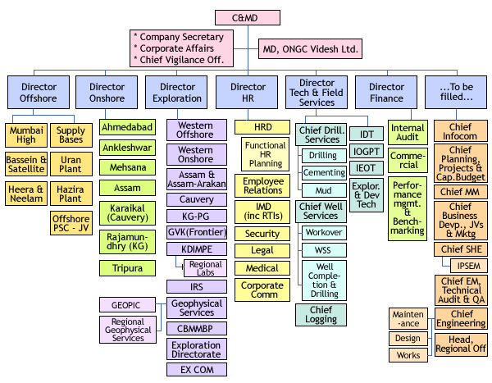

**CHAPTER 2- LITERATURE REVIEW**

**REVIEW OF LITERATURE**

***Parul Pattrick & Shabana Mazhar;2019 “***The research highlights that employees are the most valuable resource within any organization, considering them strategic assets instead of just operational expenses. It argues that strong human resource management enables organizations to develop the structures and capabilities required to face business challenges by effectively utilizing their workforce. The study outlines six primary HRM functions and suggests that even companies without a formal HR department can remain effective by redistributing HR responsibilities or utilizing support from external professional bodies***.”***

***Ankita Rathore, 2015 “***The study underscores that human resources are the most important asset within any organization, with employees at all levels being essential contributors. To secure high performance and retain talented personnel, employers must understand the expectations of their workforce. Beyond base salary, organizations should offer competitive remuneration packages that include thoughtful welfare and benefit provisions. This research investigates how employee welfare and benefits affect retention and explores their influence on job satisfaction and performance. It aims to identify strategies organizations can adopt to enhance retention and reduce turnover**”**

***Oluwatosin, Darmawan, Pedro Marsal, 2021 “***This study explores the relationship between employee welfare initiatives and workforce retention through a comprehensive literature review. It highlights key welfare dimensions such as physical and mental health support, work-life balance, and personal development. The findings reveal that managerial involvement, perceived fairness, consistent implementation, and program personalization significantly influence retention outcomes. Beyond monetary benefits, psychological connections fostered through a human- centered HR approach play a crucial role in employee loyalty. The study concludes that continuous evaluation, employee engagement, and a supportive organizational culture are essential for enhancing retention and informing sustainable HR policies**.”**

***E Teti, M Androitto 2013 “***Research in corporate social responsibility highlights employees as key stakeholders, with companies increasingly viewing their workforce as a strategic asset. Top firms are investing heavily in employee welfare and benefits. A cross-analysis based on employee surveys from a major multinational revealed key findings: women slightly value benefits more than men; benefit satisfaction generally increases with job level, except among factory workers; age and tenure have little impact on perceived benefit utility; and some low-cost benefits offer higher value to employees than more expensive, exclusive ones***.”***

**PLAN OF THE STUDY**

**Objectives of the study:**

* **To identify the key welfare schemes implemented at ONGC** (e.g., healthcare, housing, education benefits, retirement benefits, recreational facilities).
* **To assess employee awareness and utilization of the existing welfare schemes**.
* **To examine the impact of welfare schemes on employee satisfaction and motivation**.
* **To analyze the correlation between welfare benefits and employee retention rates** at ONGC.
* **To compare employee retention among departments or job levels** based on their access to and satisfaction with welfare schemes.
* **To identify gaps or shortcomings in the existing welfare policies** from the perspective of employees.
* **To gather employee suggestions on improving current welfare schemes** to better meet their needs and enhance retention.
* **To evaluate the cost-effectiveness of the welfare programs in relation to their impact on retention**.
* **To benchmark ONGC’s welfare policies against other leading public and private sector organizations** in India.
* **To provide actionable recommendations to HR and management** for optimizing welfare schemes to improve retention
* To identify the **factors affecting employee commitment.**

**Focus of the study:**

This study is focused on examining the **effectiveness of employee welfare schemes at ONGC** (Oil and Natural Gas Corporation) and their role in enhancing **employee retention**. In today’s competitive and dynamic business environment, employee retention has become a critical aspect of human resource management. Organizations like ONGC, being large public sector enterprises, invest significantly in various welfare schemes with the intent to improve employee well-being, increase job satisfaction, and reduce turnover.

The study seeks to understand **how these welfare schemes—ranging from health care, housing, education assistance, transport, recreation, retirement benefits, and other support services— affect employees’ decisions to remain with the organization**. It aims to explore both the tangible and intangible value these schemes provide to employees and how they contribute to a positive organizational climate.

A key area of focus is the **employees' perception of the adequacy, fairness, and usefulness of these schemes**, as well as their **level of awareness and engagement** with them. The study also attempts to assess whether these schemes align with employees’ actual needs and expectations, and how they compare with welfare practices in similar organizations.

The research particularly concentrates on:

* The range and types of welfare schemes provided by ONGC.
* Employee awareness, access, and utilization of these schemes.
* The psychological and practical impact of welfare provisions on employee retention.
* Identifying whether these schemes meet the evolving needs and expectations of ONGC employees.

**STUDY ON WELFARE SCHEMES BY ONGC**

Employee welfare is a key component of Human Resource Management in public sector enterprises like ONGC (Oil and Natural Gas Corporation). Welfare schemes go beyond statutory requirements to provide employees with a sense of security, belonging, and care. These schemes are designed to improve the quality of work life, promote well-being, and enhance employee satisfaction, which directly impacts employee retention and organizational loyalty. ONGC, as a Maharatna PSU, has established a wide range of employee welfare programs aimed at promoting both professional and personal development.

**Concept of Employee Welfare**

**Employee welfare** is a significant aspect of social welfare, referring to the state of happiness, health, and overall satisfaction experienced by employees in the workplace. According to the **Oxford Dictionary**, employee or labour welfare encompasses efforts made to enhance the quality of life for workers.

As defined by the **Labour Investigation Committee (1946)**, employee welfare includes all initiatives—whether undertaken by employers, the government, or other organizations—that contribute to the intellectual, physical, moral, and economic well-being of workers. These efforts go beyond legal obligations, or the standard benefits typically agreed upon in employment contracts.

In broader terms, employee welfare can be seen as a **comprehensive and evolving concept** that includes a variety of services, amenities, and facilities provided to employees in addition to their wages and legally mandated benefits. These welfare activities are generally classified into **statutory** and **non-statutory** categories:

* **Statutory Welfare**: These are welfare measures that are legally required under various labor laws, such as the Factories Act. Employers are legally bound to provide them.
* **Non-Statutory Welfare**: These are optional welfare initiatives provided by employers or employee associations, which are not legally mandated. These can be further divided into:
  + **Voluntary Welfare**: Activities undertaken solely by the employer

out of goodwill.

* + **Mutual Welfare**: Activities jointly initiated by both employers and

employees.

Additionally , welfare activities are categorized based on their location:

* **Intramural Welfare**: Initiatives provided **within** the workplace premises (e.g., canteen, restrooms, first aid).
* **Extramural Welfare**: Services offered **outside** the workplace (e.g., housing, education for employees' children, transportation facilities).

Employee benefits encompass much more than just fringe benefits; they represent a comprehensive package designed to help employees maintain a healthy balance between their personal and professional lives. These benefits typically include health care, welfare programs, and retirement plans offered by the organization to safeguard employees' financial stability and social well-being. The significance of welfare and benefit initiatives can be summarized as follows:

* Such programs contribute to creating a healthier and more supportive work environment.
* Providing facilities like housing schemes, medical care, educational support, and recreational amenities for employees and their families enhances their overall standard of living. This, in turn, allows employees to focus better on their work, leading to improved productivity.
* Offering effective welfare and benefit measures helps organizations maintain a stable workforce by increasing employee retention. When employees feel valued through these provisions, they tend to develop greater motivation, demonstrate loyalty, and actively engage in roles.

**Labour Welfare – Concept and Meaning**

Labour welfare refers to the efforts made by employers, trade unions, government bodies, and other organizations to ensure the well-being and comfort of workers. These welfare measures go beyond the regular wages and are aimed at enhancing the overall quality of work life for employees. The primary objective of such initiatives is to maintain high levels of morale, motivation, and job satisfaction, which in turn contributes to better employee retention and organizational commitment.

Welfare activities typically include maintaining safe and healthy working conditions, providing healthcare and insurance facilities, promoting good industrial relations, and offering protection against risks such as illness, accidents, and unemployment—for both employees and their families.

According to the **Oxford Dictionary**, labour welfare encompasses “efforts to make life worth living for workmen.” These efforts stem from an organization's sense of **social responsibility**, a commitment to **democratic values**, and genuine concern for the well- being of its workforce.

The **International Labour Organization (ILO)** defines labour welfare as the range of services, facilities, and amenities made available to workers either within or near the workplace, with the purpose of enabling them to perform their duties in safe, healthy, and pleasant conditions.

Such provisions are intended to promote both physical well-being and psychological morale among employees.

**Theoretical Framework: Theories of Labour Welfare**

Labour welfare activities are guided by several theories that explain **why employers, governments, and organizations provide welfare measures to workers**. These theories form the conceptual foundation for understanding the purpose and motivation behind such initiatives. The main theories are as follows

**Policing Theory**

This theory assumes that **employers are naturally self-interested** and may not care about workers’ welfare unless forced to. According to this view, **without rules, laws, and government supervision**, employers might avoid even basic welfare responsibilities. Therefore, the state must step in to enforce **minimum welfare standards** to prevent exploitation and ensure fair treatment of workers.

**Religious Theory**

This theory is based on the idea that **human beings are influenced by religious beliefs**. Employers may provide welfare facilities as a **moral or spiritual duty**, believing that doing good deeds will bring rewards either in this life or after death. However, this approach treats welfare as charity, not as a right of workers.

**Philanthropic Theory**

The philanthropic theory suggests that some welfare activities are driven by **kindness, compassion, or sympathy**. Employers may offer welfare benefits because they **genuinely care about their workers' well-being**. While this is positive, such actions depend on personal values and are not guaranteed across all organizations.

**Paternalistic or Trusteeship Theory**

This theory sees the **employer as a caretaker or guardian** of both the business and its workers. It assumes that workers are like dependents who need guidance and support because they may not always be aware of their own rights or needs. As a result, employers have a **moral responsibility** to look after their employees’ well-being using the company's resources.

**Placating Theory**

As workers become more aware of their **rights and begin demanding better wages and conditions**, this theory suggests that welfare measures are used as a way to **calm or satisfy them**. These welfare benefits are seen as a way to **reduce unrest or dissatisfaction** and maintain industrial peace.

**Public Relations Theory**

This theory views welfare programs as a tool to **build a positive image** of the organization. By offering good facilities and support to workers, companies create **better relations with employees and the general public**. It works like a form of advertisement, showing that the company is caring and responsible.

**Functional Theory**

The functional theory is based on the belief that a **healthy, happy, and satisfied worker is more productive**. Therefore, welfare measures are used as a tool to **improve worker efficiency and organizational performance**.

**Employee Welfare Measures**

ONGC, over a period of time, has introduced several welfare schemes for its employees and their dependent family members in order to improve their quality of life, besides improving the morale and motivation of its employees. The following are some of the Welfare Schemes:

* 1. **Medical Facility**

All regular employees and their dependent family members are provided free medical facility through the dispensaries/hospitals of ONGC and through empaneled hospitals.

* 1. **Housing Facilities**:

ONGC has established townships at most of its work centers. In addition, ONGC also takes houses on lease for its employees. Bachelor Accommodation is provided to employees who are unable to take their family along with them on their transfer. There are norms for providing furniture and fixtures in bachelor accommodation.

* 1. **Education Facilities**:

ONGC has established Project Schools at most of its work centers comprising of Kendra Vidyalayas. Shishu Vihar Schools are established for imparting pre-school and Kindergarten level education. These schools are being managed by the ONGC Officers’ Mahila Samiti at the work centers.

* 1. **Canteens/ Cafeterias**

ONGC provides canteen facility at all its work centers on ‘No Profit’ basis. In operational areas such as drill sites and offshore where extended stay is involved, free boarding and lodging facilities are provided by the company to its employees.

* 1. **Crèche facilities**

ONGC has policy to provide crèche facilities for employees, male and female, having pre-school and primary school going children at all its locations.

* 1. **Resident Welfare Associations**

Resident Welfare Associations have been set up at various residential townships of the company at work centers for ensuring better customer satisfaction among residents by way of speedy redressed of complaints, organizing socio-cultural activities and other welfare initiatives for the residents.

* 1. **Employee Welfare Committees**

Employee Welfare Committees have been set up in all work centers of the company for promoting and organizing sports, games, literary and cultural activities among employees and their family members.

* 1. **ONGC Officers’ Mahila Samiti (OOMS)**

OOMS is actively involved in various activities for meeting the social objectives of the Corporation like running crèches and Shishu Vihar Schools, organizing health awareness camps, helping poor and needy, differently abled children and arranging vocational training and conducting adult education programs.

* 1. **Loans and Advances**

1. **Children Education Loan**

ONGC employees can avail this loan up to 40 lakhs for higher education of their dependent children in India and abroad

1. **Conveyance Advance**

The employees can avail conveyance for the purchase of car/two-wheeler.

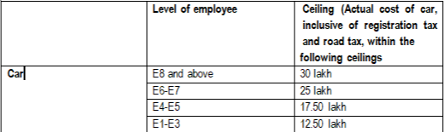

1. **House Building Advance**

House Building Advance is admissible to regular employees once in the entire service period. The advance can be extended for any one of the following purposes :-

vi) Purchase of plot of land and construction of house thereon.

vi) Construction of a house on the plot of land owned by the employee or jointly owned with his/her spouse, subject to jointly mortgaging the property in favor of ONGC.

vi) Purchase of ready built / under construction flat from Private Builders / Co- operative Housing Society

vi) Purchase of plot of land through Co-operative Societies and construction of house

/ flat etc. thereon.

vi) Purchase of flats from State Housings Boards / Authorities Housing Authorities / Agencies.

vi) Repayment of housing loan taken from banks/ financial institutions for construction/ purchase of house

|  |  |  |  |  |
| --- | --- | --- | --- | --- |
| Level | Monetary Ceiling for construction / purchase of House (A) | Monetary ceiling for  extension / bigger and better house (in  Rs.) (B) | Monetary ceiling for renovation (In Rs.) (C) | Total admissible amount under ONGC HBA  Scheme (In  Rs.) (A+B+C) |
| Executives of  E-5 level & above | 53 Lakh | 15 Lakh | 7 Lakh | 75 Lakh |
| Executives upto E-4 level and S  level employees | 44 Lakh | 15 Lakh | 7 Lakh | 66 Lakh |
| W & A level  employees | 36 Lakh | 15 Lakh | 7 Lakh | 58 Lakh |

**a. Furniture and Household Goods Purchase Scheme**

|  |  |
| --- | --- |
| **Level** | **Approved amount (in lakh)** |
| E9 | 10.00 |
| E8 | 8.00 |
| E7 | 7.00 |
| E6 | 6.00 |
| E5 | 4.75 |
| E4 | 3.75 |
| E3 | 3.10 |
| E2 | 2.60 |
| E1 | 2.20 |
| E0 & S level | 1.75 |
| A & F level | 1.45 |
| W level | 1.10 |

**Other Work-related facilities Laptop Advance**

|  |  |
| --- | --- |
| **Level of employee** | **Cost Ceiling (in Rs.)** |
| E1 and above | 1,50,000/- |
| E0 and S level | 90,000/- |
| Non-executives other than S level | 75,000/- |

**Mobile Handset**

|  |  |
| --- | --- |
| **Level** | **Cost Ceiling (in Rs.)** |
| E8-E9 | 90,000/- |
| E7 | 80,000/- |
| E6 | 70,000/- |
| E5 | 65,000/- |
| E3-E4 | 55,000/- |
| E1-E2 | 50,000/- |
| E0 | 30,000/- |
| S-Level | 30,000/- |
| A & F-level | 18,000/- |
| W-Level | 15,000/- |

**SIM and Internet facility provided by ONGC**

|  |  |
| --- | --- |
| **Level** | **Ceiling for mobile connection** |
| E9/E8/L-I, All Key Executives, Head of Institutes, Chief of Services | 10000 |
| L-II or E-7 | 5000 |
| L-III or E6 | 3000 |
| E-5 & E4 | 2000 |
| E-1 to E-3 | 1000 |
| E-0 and S level | 1000 |
| Non-executives other than S level | 750 |

|  |  |
| --- | --- |
| **Level** | **Existing Ceiling for internet facility** |
| E7 and above | 1200 |
| E5 & E6 | 900 |
| E-1 to E-4 | 700 |
| E-0 and S level | 500 |
| Non executives other than S level | 450 |

**Briefcase Scheme**

|  |  |
| --- | --- |
| **Level of employee** | **Cost Ceiling (in Rs.)** |
| W,F and A | 6000/- |
| S level & E-0 to E-2 | 9000/- |
| E-3 to E-5 | 14000/- |
| E-6 to E-7 | 18000/- |
| E8 and above | 20000/- |

1. **Separation Benefits**
   1. **Post Retirement Benefit Scheme (PRBS)**

Scheme introduced in ONGC w.e.f. 01.04.1990 for executives with due approval of Ministry of Petroleum and Natural Gas, Government of India. The benefit in revised PRBS scheme is contribution based. The contribution is made by both employee & employer as per DPE guidelines.

The annuity is purchased from the insurance company at the time of separation of an employee with the total corpus at the credit on the date of superannuation, as per option exercised by employee.

* 1. **Composite Social Security Scheme (CSSS)**

In order to provide adequate social security cover to employees, ONGC introduced CSSS with effect from 01.06.1998 which is self-contributory with financial support from the company, in the event of death of the employee while in services or illness leading to permanent total disability causing cessation of employment.

* 1. **Employment Assistance scheme**

One dependent member of an employee who dies due to accident while on duty or as a result of insurgency or extremist/terrorist attack or suffers permanent total disability due to accident while on duty and is in financial distress shall be considered for employment in ONGC in addition to benefits admissible under CSSS

* 1. **Other Insurances**

b) Rs. 10 lakh life insurance from LIC under Group Leave Encashment Scheme

b) Group Insurance scheme of Rs. 7.02 lakh in lieu of EDLI

* 1. **Agrani Samman**

ONGC introduced ‘Agrani Samman’ Ex-gratia Benefit Scheme w.e.f. 1.1.2003 for its pre- 15.10.1959 employees and those post 14.10.1959 employees who have superannuated/voluntarily retired/died while in service prior to 1.4.1991 (in case of executives) and 16.11.1995 (in case of non-executives) after rendering minimum ten years of service.

* 1. **Asha Kiran**

The objective of the scheme is to provide financial assistance to the employees retired prior to 01.01.2007 for meeting the emergency needs of those retired employees or their surviving spouse (in the case of deceased employees) who are not able to cope up with distressful emergency situations.

* 1. **Post Retirement Medical Facility**

Free medical facilities are extended at ONGC Hospitals/Health Centers and empaneled hospitals to retired employees, their spouse and their dependent parents. Lifetime medical facility is provided to the mentally or physically totally invalid children of retired employees. Retired employees can also avail in-patient treatment at empaneled hospitals through ONGCares card.

* 1. **Felicitation Scheme**

In recognition of contribution towards growth of ONGC in its’ formative and consolidation phase, the scheme for felicitation of retired employees was introduced for superannuated / voluntary retired employees. The retired employees are extended felicitation amount on attaining the age milestones of 70, 75, 80, 85, 90, 95 and 100 years.

**CHAPTER 3 - RESEARCH METHODOLOGY**

**Objectives of the Study**

* To analyze Employee Welfare Scheme at ONGC.
* To assess employee parcipation and satisfaction with Welfare policies.
* To compare ONGC’s policies with best practices from literature and industry standards.
* To suggest improvements in the existing Employee Welfare Scheme at ONGC.based on findings.

**Sources of Data**

**Primary Data**

Primary data refers to the first-hand information collected directly by the researcher for the specific purpose of the study. In this research, primary data was gathered through a **structured questionnaire survey** administered to employees of ONGC. The questionnaire was designed to assess employee perceptions regarding various Human Resource policies and practices within the organization.

The responses provided by employees offered valuable insights into their experiences, satisfaction levels, and suggestions for improvement. This data was crucial in understanding the practical application and effectiveness of ONGC's HR policies from the perspective of the workforce.

**Secondary Data**

Secondary data refers to information that has already been collected and published by other individuals or organizations, and is utilized in this study to support, compare, and validate the primary research findings.

The secondary data for this research was collected from the following sources:

* **ONGC Human Resource Manual**: To understand the official Employee welfare policies and frameworks.
* **Annual Reports of ONGC**: To gather organizational data, HR statistics, and policy changes over time.
* **Previously published dissertations and academic papers** related to HR practices in the oil and gas sector.
* **Online articles, research publications, and industry reports** providing context, trends, and comparative practices in Human Resource Management.

This combination of primary and secondary data provided a strong foundation for critical analysis and practical recommendations.

**Data Collection Tools**

* **Questionnaire**: A structured questionnaire was prepared using Google Forms

**Link to Questionnaire – (https://forms.gle/cACugqXJWajCrM3L7)**

* The survey was shared with a sample of ONGC employees across various departments to ensure diversity in responses.

**Sampling Method and Size**

Purposive sampling, also known as judgmental or selective sampling, is a non-probability sampling technique where researchers intentionally select participants based on specific characteristics or criteria relevant to the study. This contrasts with random sampling, which aims for a representative sample of the broader population. Purposive sampling is particularly useful in qualitative research where in-depth understanding of a specific phenomenon or group is desired.

A **purposive sampling** technique was used, targeting ONGC employees who were accessible and willing to participate in the survey. The final sample size consisted of **400** respondents.

**Tools and Techniques for Data Analysis**

* Data from the questionnaire was analyzed using **Microsoft Excel / Google forms**.
* Descriptive statistics such as percentage analysis and charts were used for interpreting quantitative responses.
* Thematic analysis was used for open-ended questions to identify key employee concerns or suggestions.
* Secondary data was analyzed using **content analysis** to extract relevant Welfare policy insights and industry comparisons.

**Power BI-** · Power BI is Microsoft's business analytics platform that helps you turn data into actionable insights. It helps in transforming raw data into interactive dashboards and reports.

To ensure effective analysis and visualization of the data collected during the internship, Power BI was used as the primary analytical tool. Power BI is a powerful business analytics software developed by Microsoft, which enables users to visualize data, identify trends, and generate actionable insights through interactive dashboards and reports.

**Limitations of the Study**

* Limited time frame for data collection and analysis.
* The sample size may not fully represent the views of all ONGC employees.
* Some employees were hesitant to share candid feedback due to organizational sensitivity.

**RESEARCH DESIGN**

The research design adopted for this summer internship project is descriptive in nature. It is intended to analyze and present the existing Human Resource (HR) practices at ONGC and evaluate employee perceptions regarding the effectiveness of those practices. The study uses a mixed-method approach, incorporating both quantitative (survey data) and qualitative (open-ended responses and document analysis) elements.

This design is chosen for an internship project, as it helps gather in-depth insights about organizational policies without manipulating any variables or testing hypotheses. It allows for the documentation of real-world practices and attitudes using structured data collection tools.

**Objectives of the Study**

1. To identify the various employee welfare schemes implemented by ONGC.
2. To evaluate employee awareness and utilization of these welfare schemes.
3. To assess employee satisfaction with existing welfare measures.
4. To examine the relationship between welfare schemes and employee retention at ONGC.
5. To gather employee suggestions for improving the effectiveness of welfare schemes.

**Research Approach**

This study adopts an inductive research approach, as it is aimed at drawing general insights from specific employee responses and observed practices at ONGC. Rather than starting with a theory, the research builds conclusions based on collected data and trends.

**Sample Size**

A survey was administered through Google Forms to **a sample of 400 employees** to assess their overall satisfaction with the existing employee welfare schemes. The questionnaire consisted of 29 questions, including 2 specifically directed toward female employees. The objective of the survey was to evaluate whether the current welfare initiatives contribute to employee retention, as well as to gather suggestions and identify potential areas for improvement.

**CHAPTER 4**

**DATA ANALYSIS AND INTERPRETATION**

**PART 1**

**EMPLOYEE SURVEY: QUESTIONNAIRE**

**INTRODUCTION**

As part of my summer internship project, a survey was conducted to assess the role of employee welfare schemes in influencing employee retention within the organization. The primary objective of this survey was to gather insights into how various welfare initiatives—such as health benefits, work-life balance programs, training opportunities, and employee support services—impact employees' decisions to remain with the company.

The survey was designed to ensure full confidentiality, and **all responses were collected anonymously**. Participants were assured that their input would be used solely for academic research and internal assessment purposes, with no identifying information being recorded. This approach was intended to encourage open and honest feedback, which is critical for the accuracy and reliability of the study.

The findings from this survey aim to contribute to a deeper understanding of the relationship between employee welfare and organizational retention strategies, potentially guiding future HR policies and initiatives.

# **QUESTIONNAIRE**

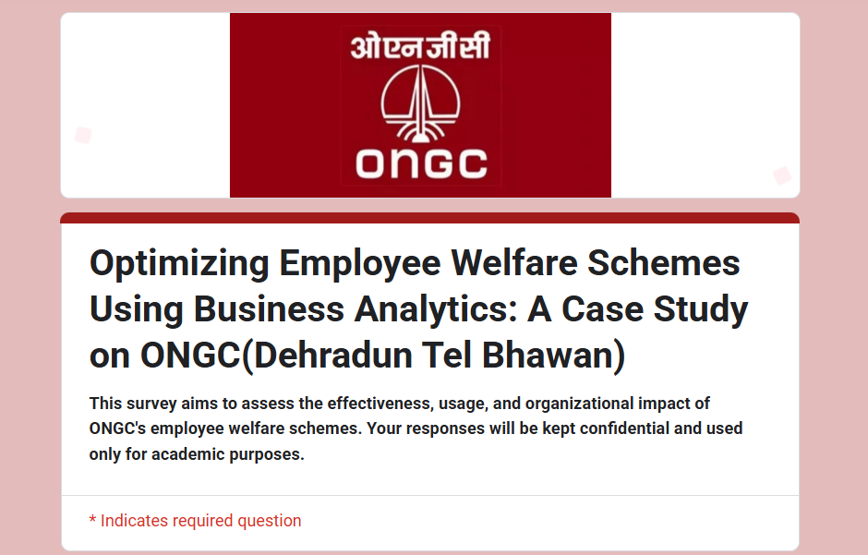

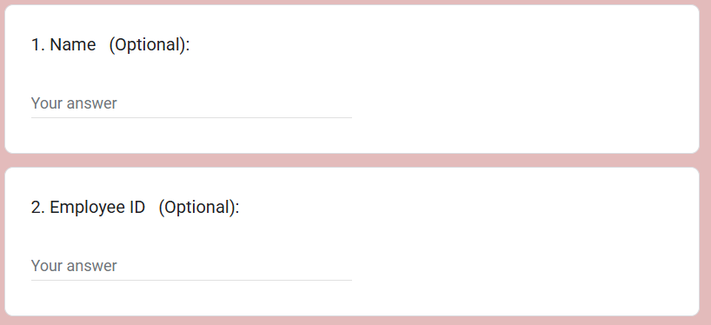

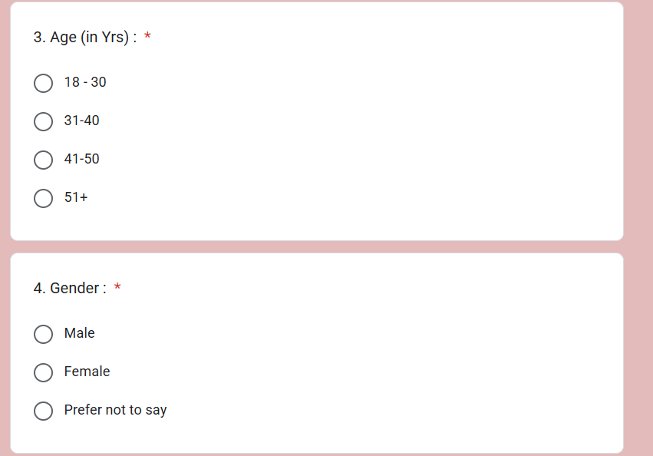

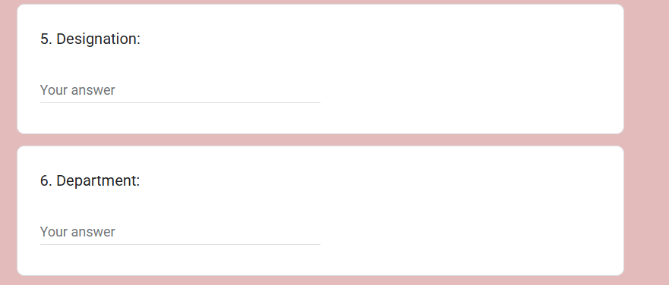

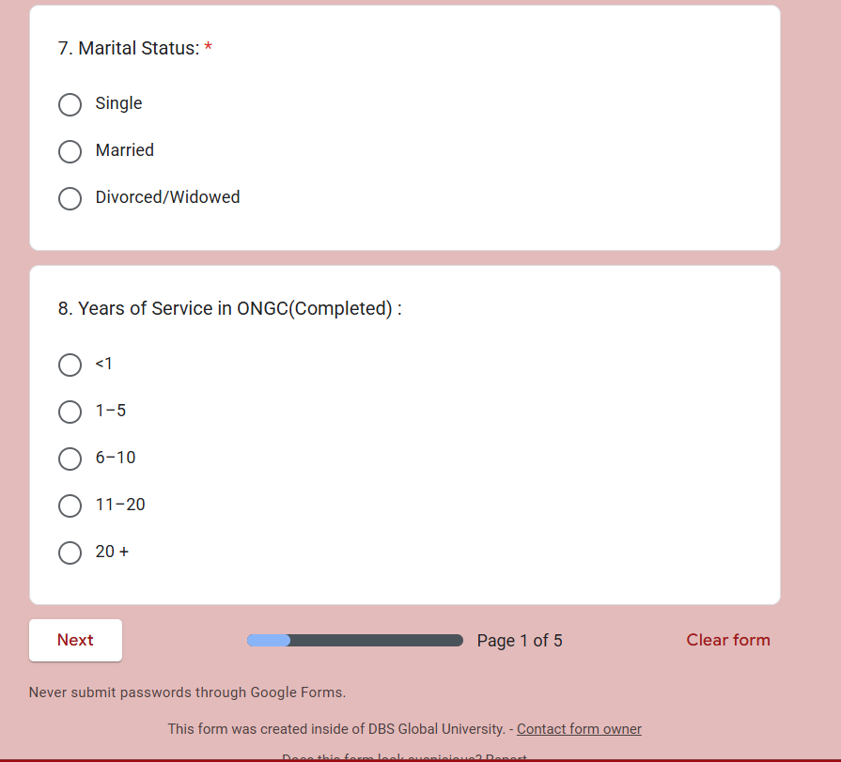

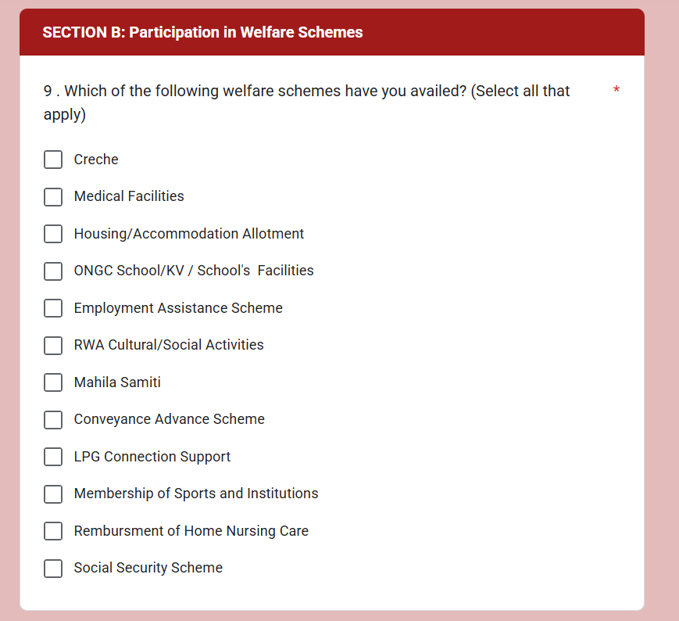

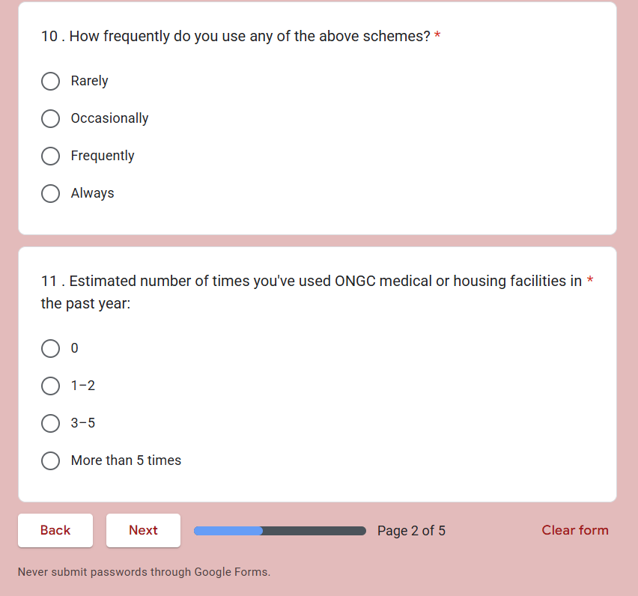

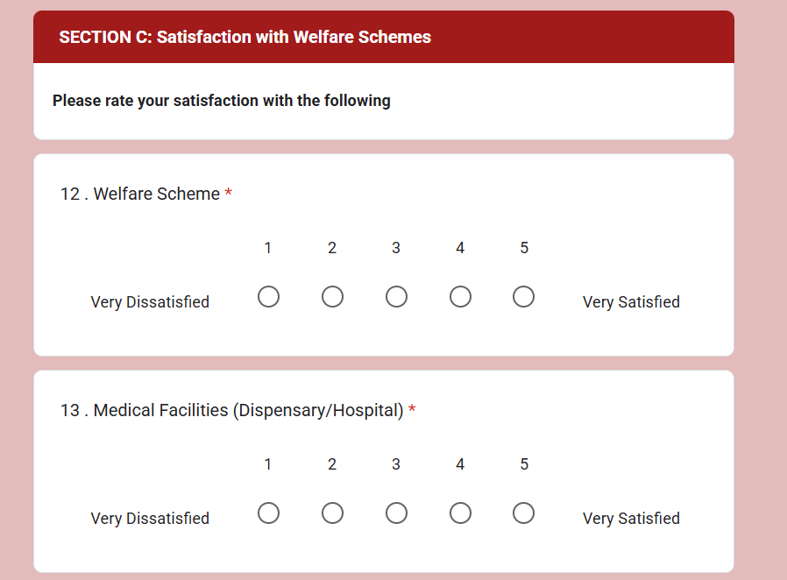 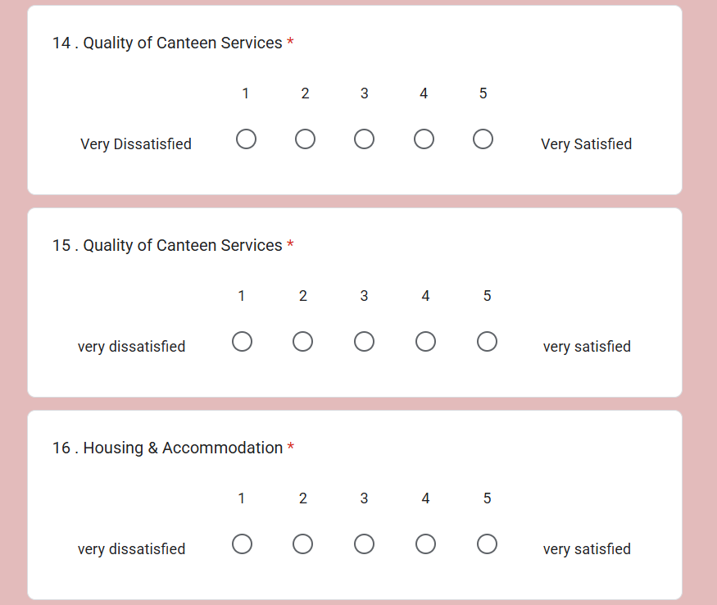 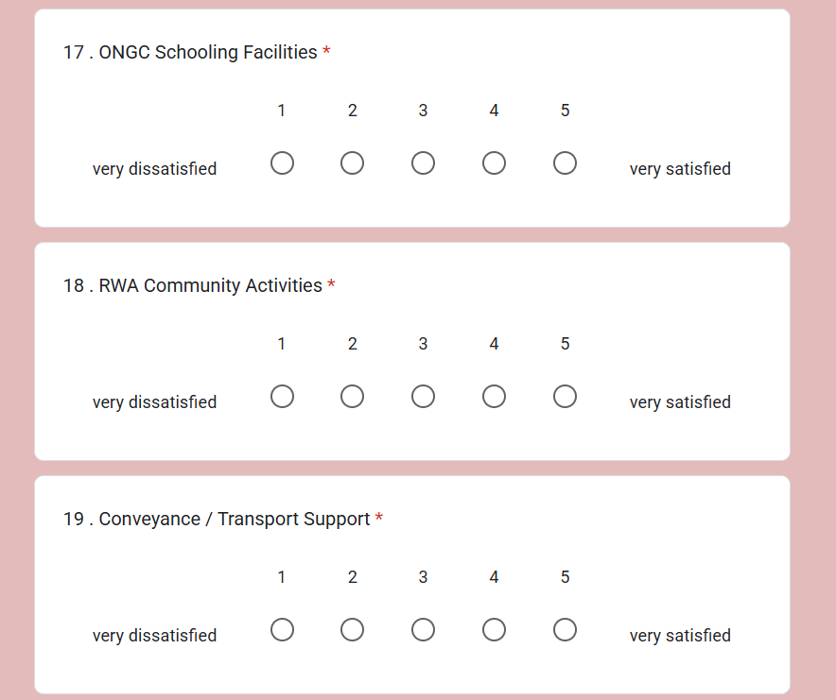 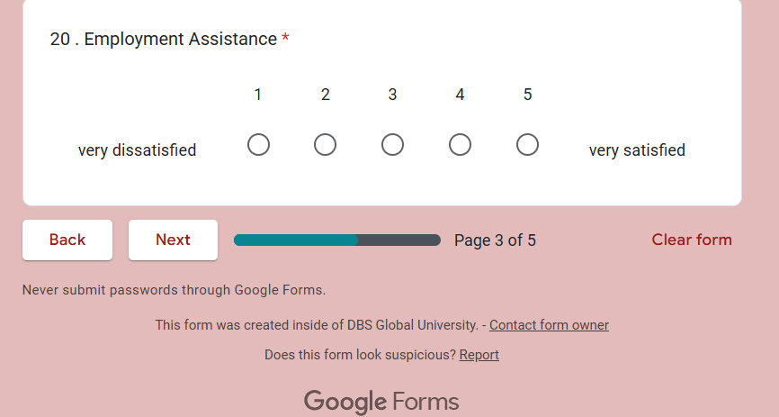 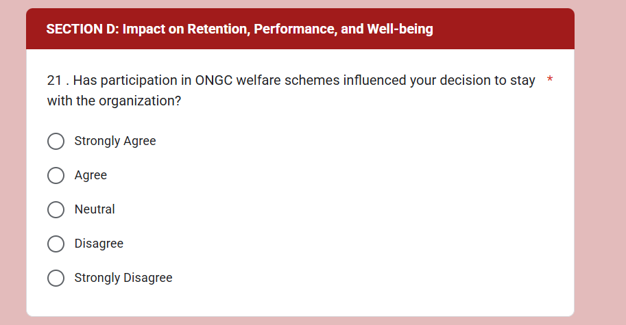 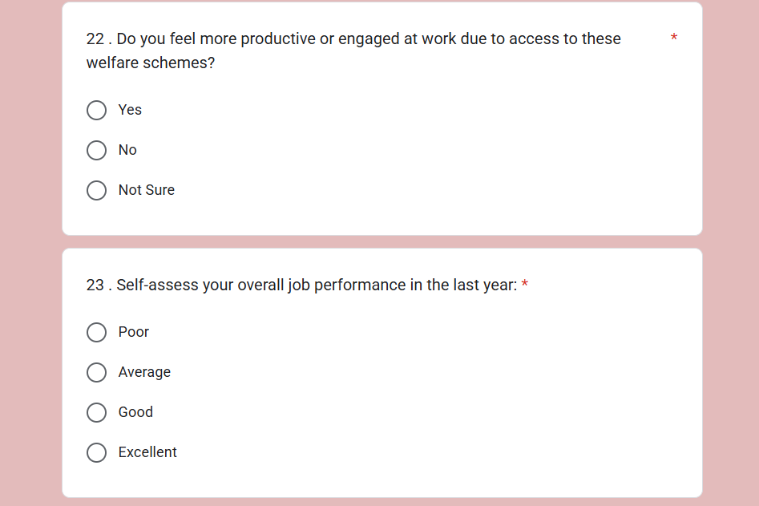 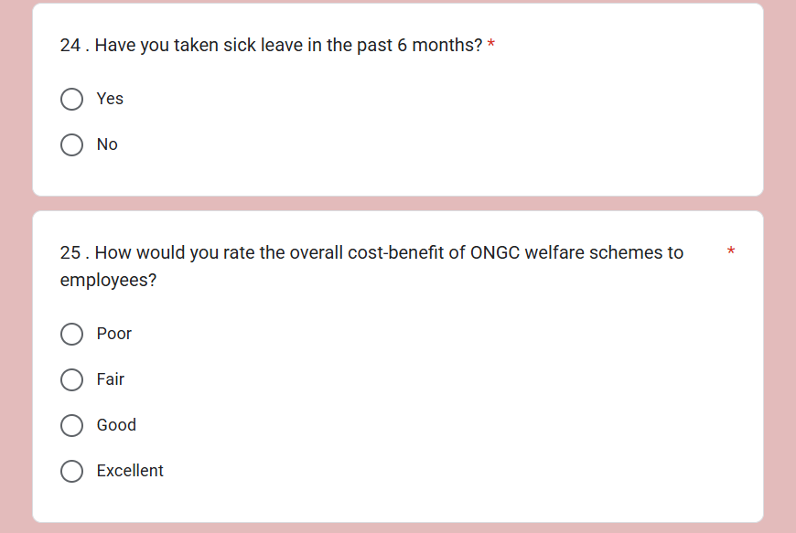 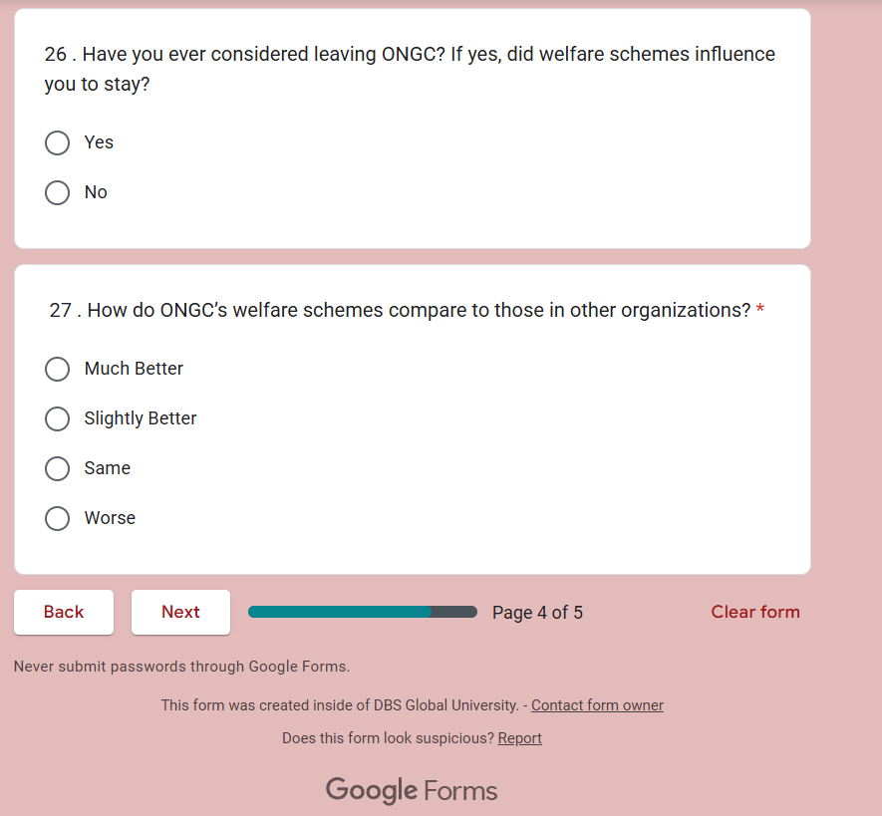 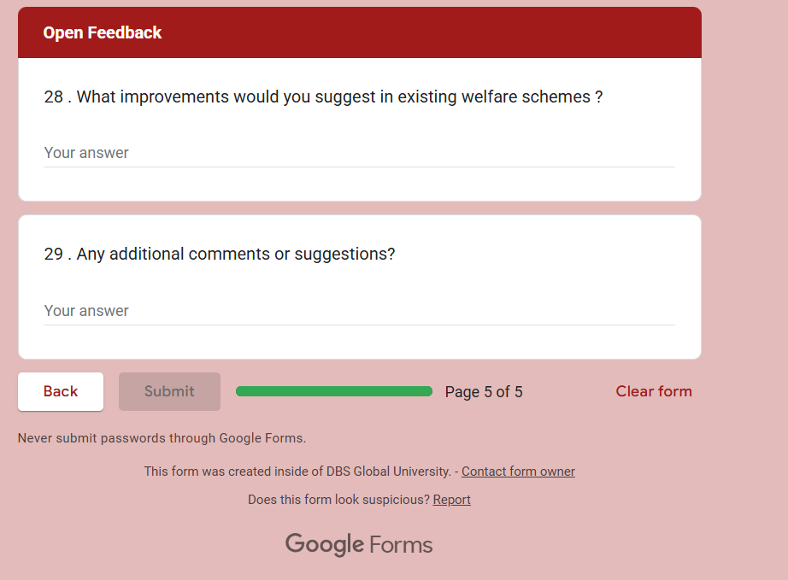

**Preview of Some Responses**

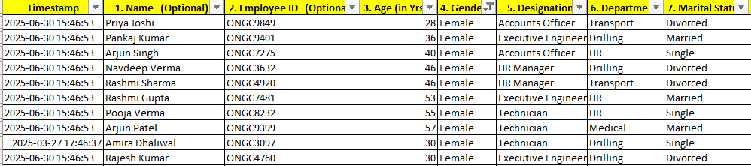

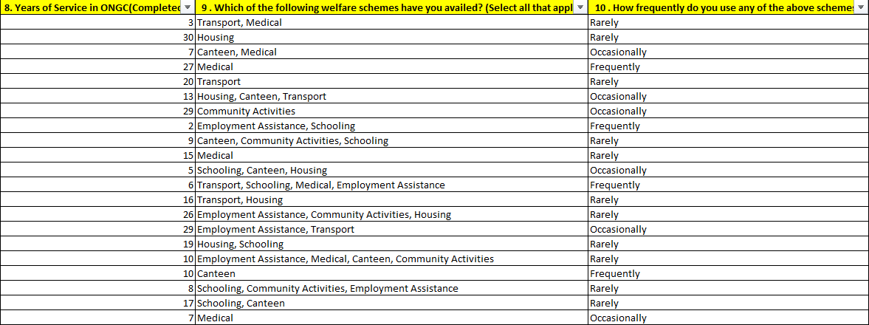 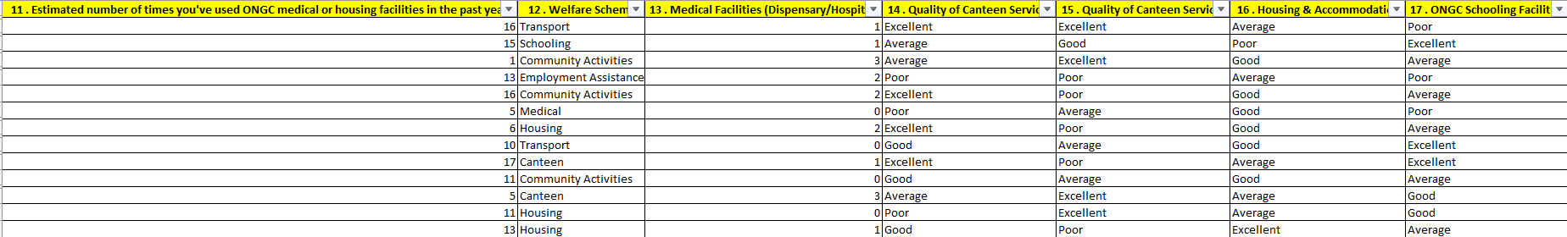 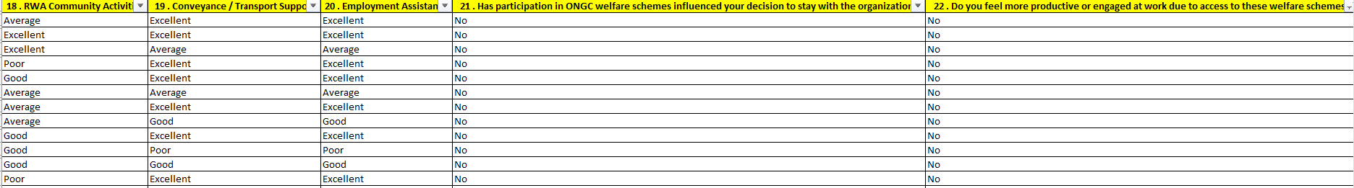

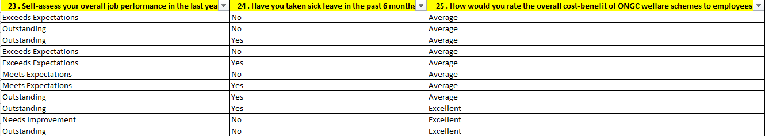

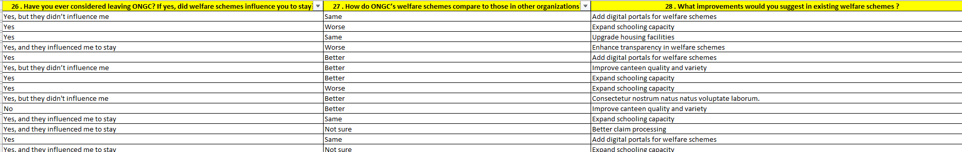

# **PART 2**

**ANALYSIS OF SURVEY RESPONSE**

**1.Participation Analysis (Some Responses)**

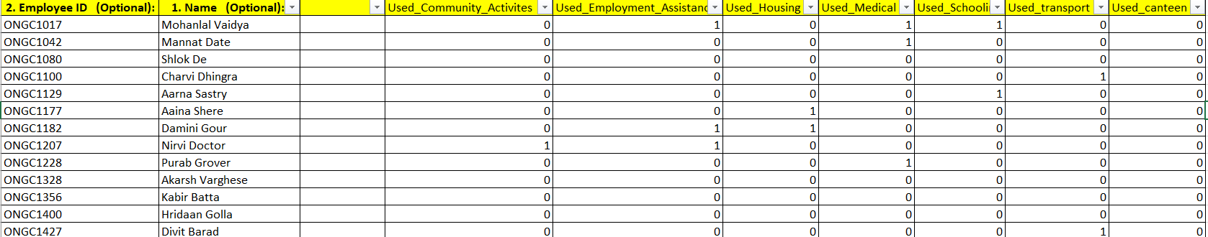

**2.Demographic Analysis(Some Responses)**

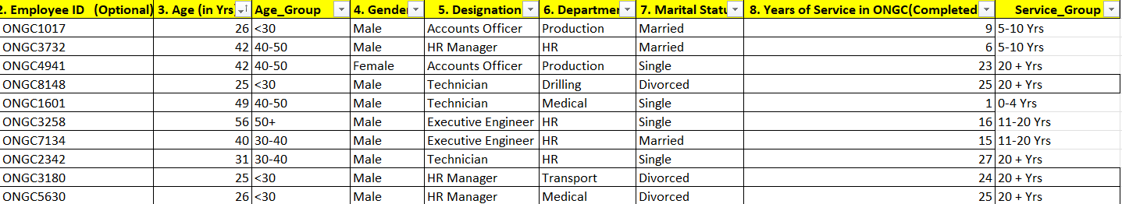

**3.Cost Vs Benefit Analysis(Some Responses)**

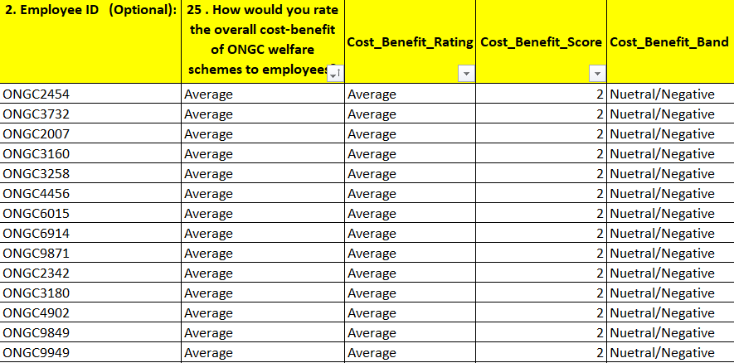

**4.Retention And Attrition Analysis (Some Responses)**

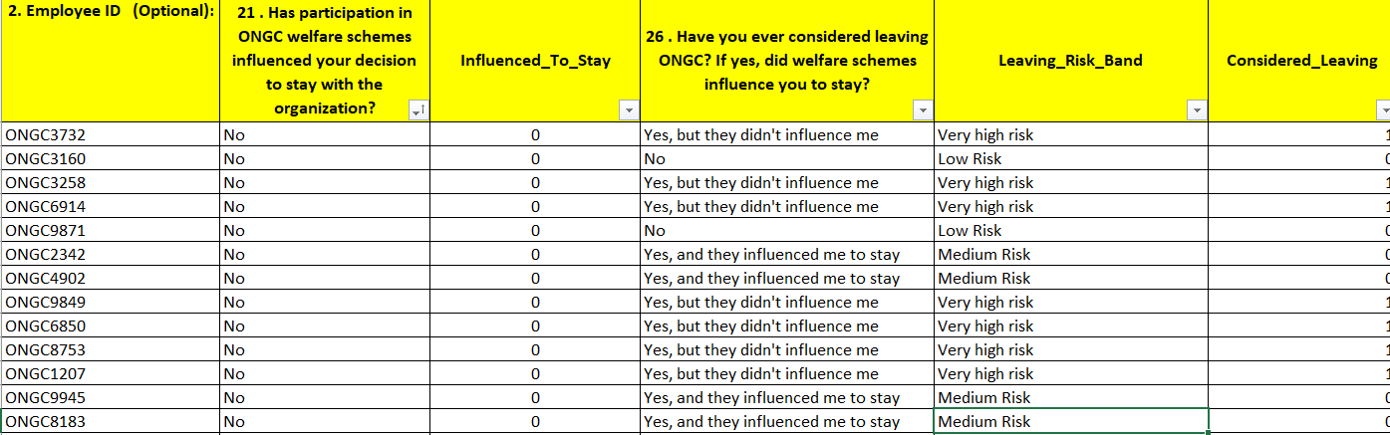

**5.Performance Metrices Analysis(Some Responses)**

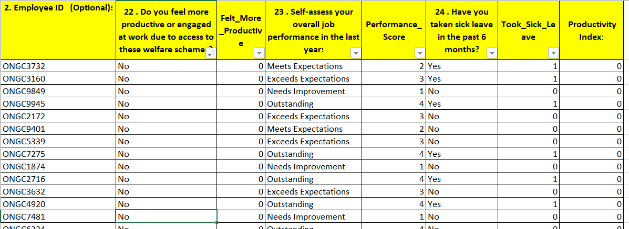



**Summary Dashboard**

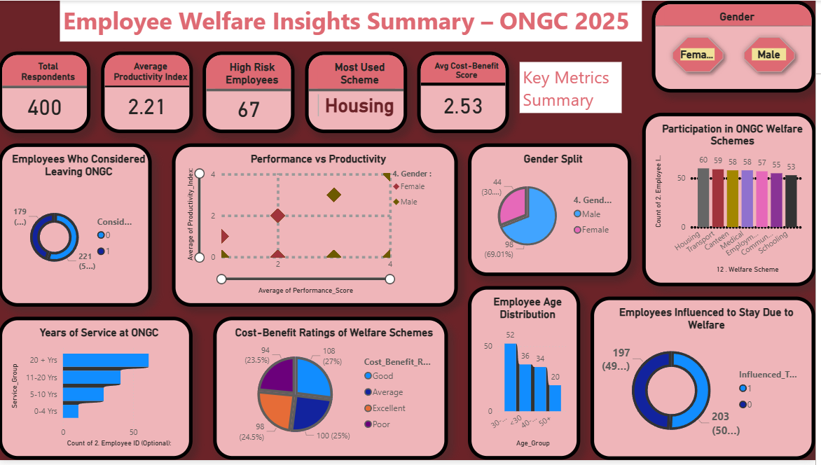

**Key Performance Indicators**

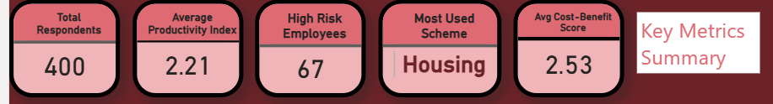

**Gender Distribution**

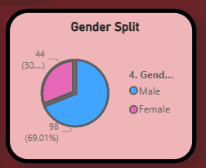 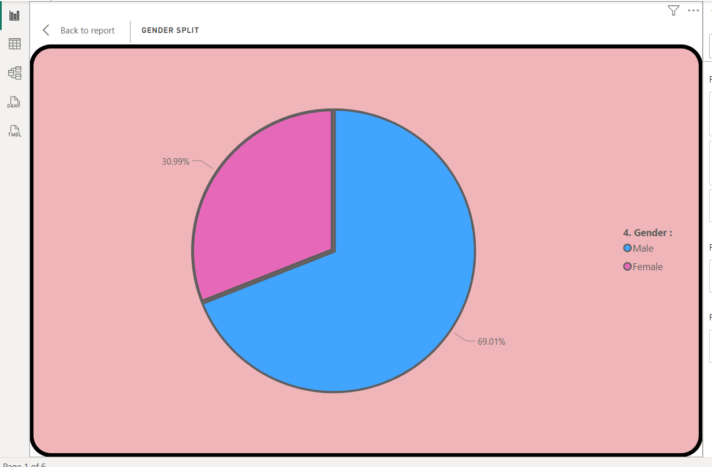

`

**Participation in ONGC Welfare Scheme**

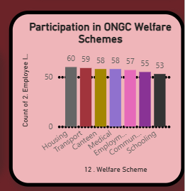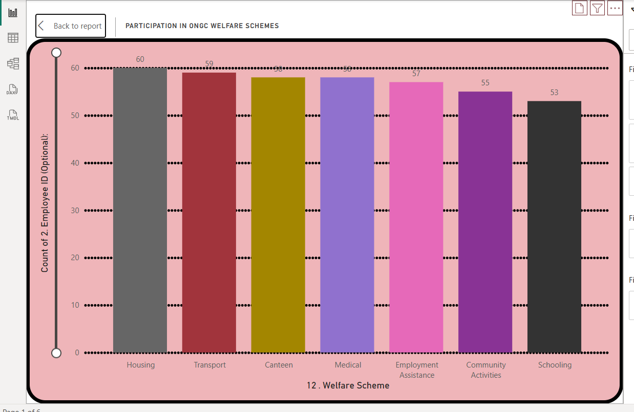

**Employees Influenced to Stay Due to Welfare Schemes**

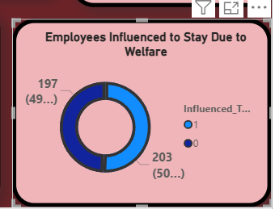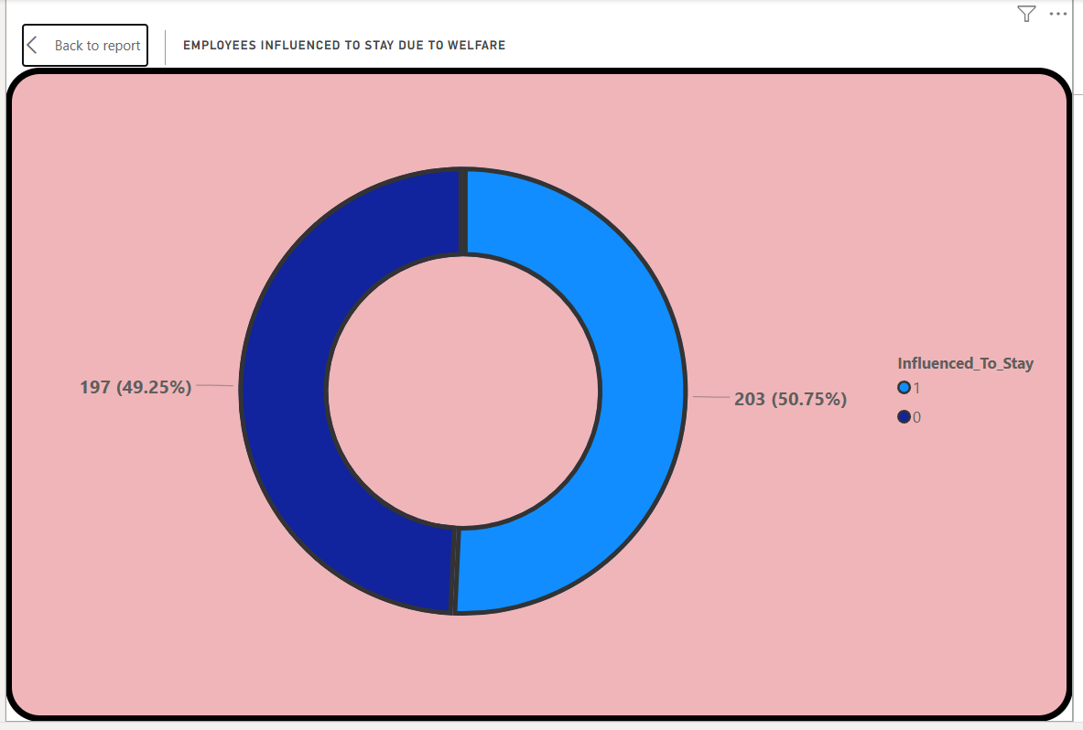

**Employee Age Distribution**

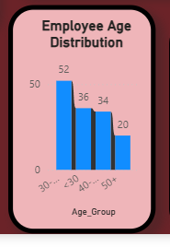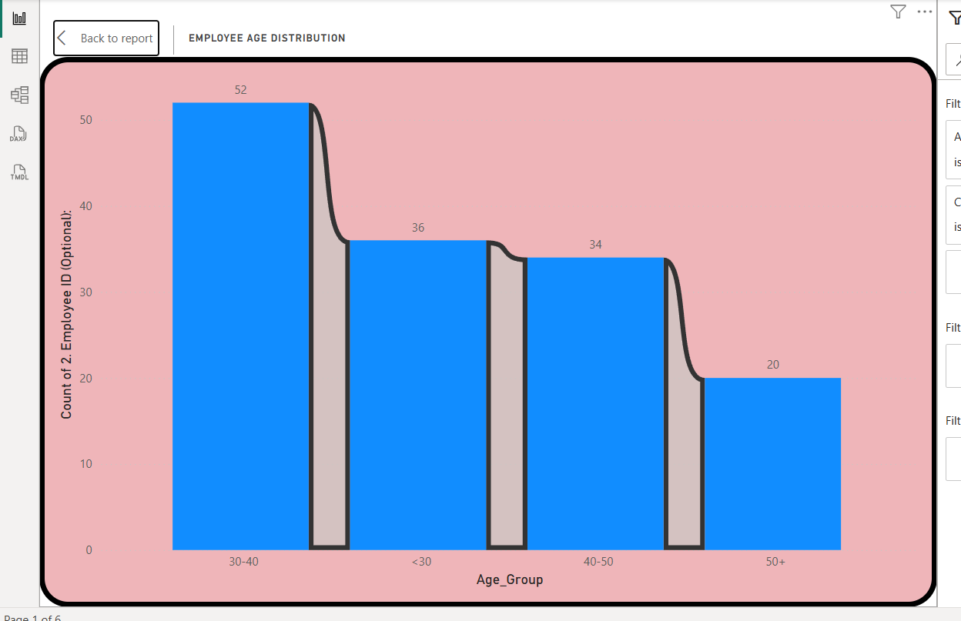

**Cost-Benefit Ratings of Welfare Schemes**

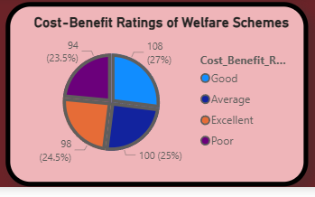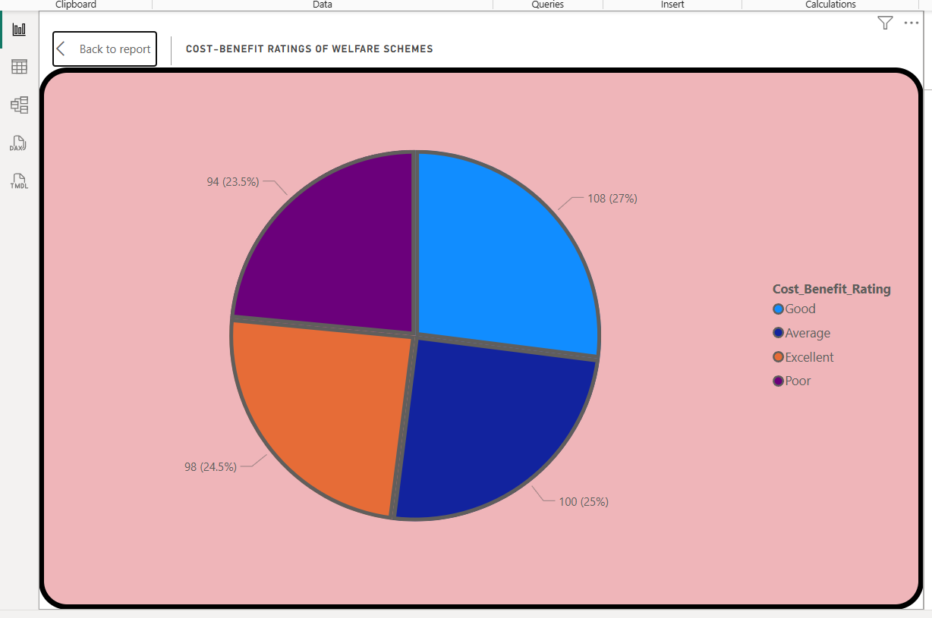

**Years of Service at ONGC**

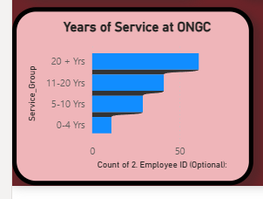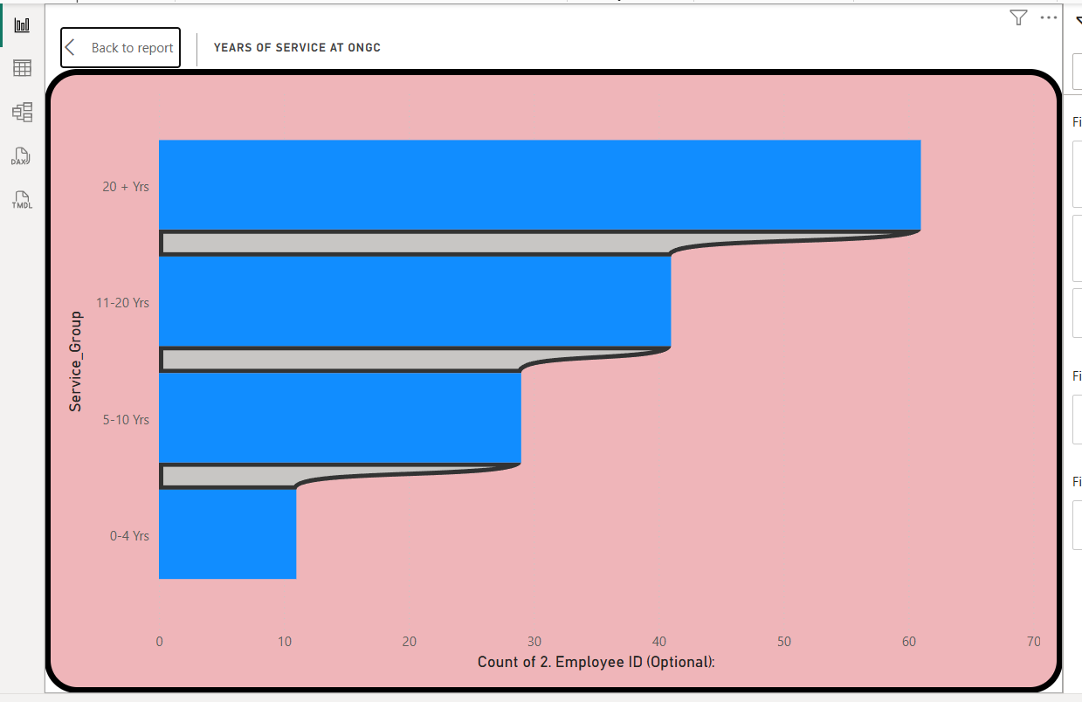

**Employees Who Considered Leaving ONGC**

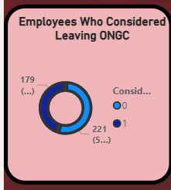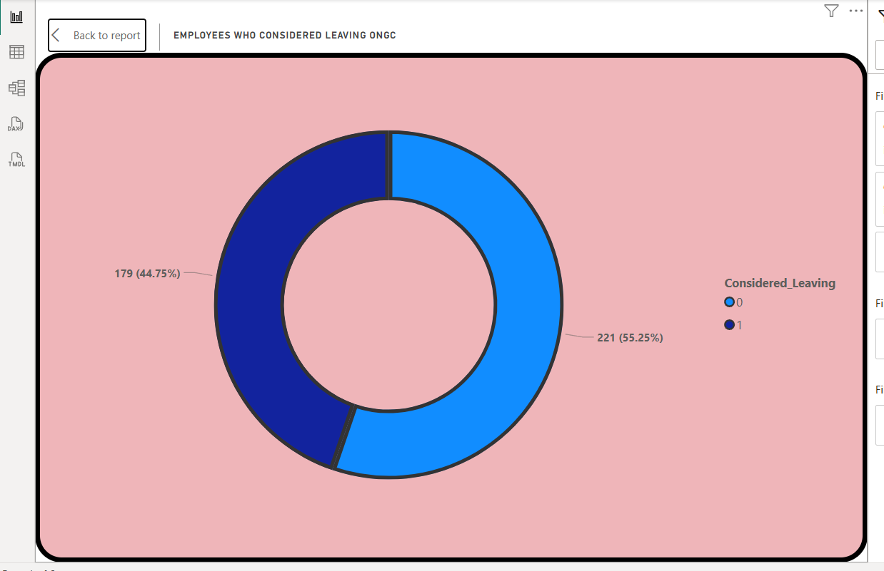

**Performance vs Productivity Matrix**

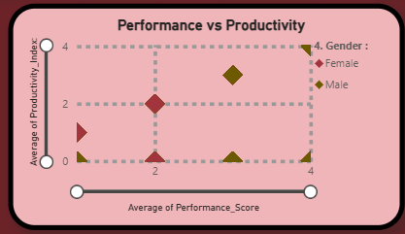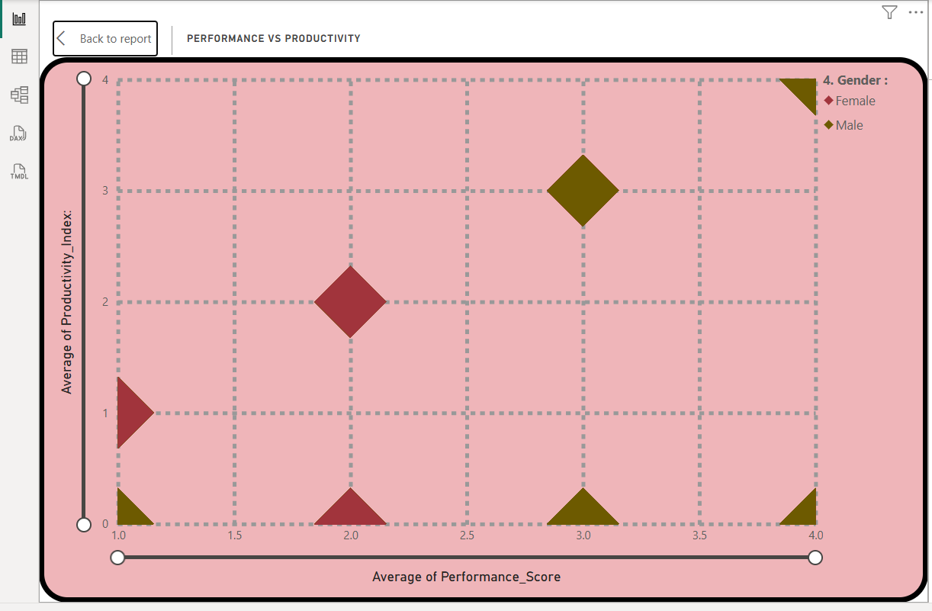

**Analysis of Summary Dashboard**

**1. Key Metrics Summary**

* Total Respondents: 400 ONGC employees participated in the survey.
* Average Productivity Index: 2.21 on a scale of 0–4, indicating **moderate productivity** across the workforce.
* High-Risk Employees: 67 employees are flagged as high risk (possibly due to **low productivity, dissatisfaction, or intent to leave**).
* Most Used Scheme: ***Housing*** welfare scheme is the **most utilized** among all provided schemes.
* Average Cost-Benefit Score: 2.53 (out of 4), suggesting employees **perceive moderate value** from welfare schemes.

**2. Employees Who Considered Leaving ONGC *(Doughnut Chart)***

* 179 employees (44.75%) have considered leaving ONGC.
* 221 employees (55.25%) have not considered leaving.
* This indicates almost half the workforce has had thoughts of leaving, a key retention concern.

**3. Performance vs Productivity (Scatter Plot)**

* Both *Male* and *Female* employees are distributed across different performance and productivity levels.
* Some employees show high performance but low productivity, which could indicate process inefficiencies or misaligned roles.
* Others show high productivity but lower performance scores, possibly due to measurement gaps or resource limitations

1. **Gender Split (Pie Chart)**

* Male: 69.01%
* Female: 30.9%
* Workforce is male-dominated, suggesting **potential for diversity** and inclusion initiatives.

1. **Participation in ONGC Welfare Schemes (Bar Chart)**

* Top participating schemes (number of employees):
  + Housing: 60 employees
  + Transportation: 59 employees
  + Medical: 58 employees
  + Entertainment: 57 employees
  + Community Development: 55 employees
  + Schooling: 53 employees
* Housing and transportation are most used; **schooling** has the **least** participation.

**6. Years of Service at ONGC (Bar Chart)**

* Majority have 20+ years of service (~50 employees).
* 11–20 years and 5–10 years follow, while 0–4 years group is the smallest.
* This shows a **strong long-term retention** pattern, but fewer new hires in recent years.

**7. Cost-Benefit Ratings of Welfare Schemes (Pie Chart)**

* Good: 108 (27%)
* Excellent: 100 (25%)
* Average: 98 (24.5%)
* Poor: 94 (23.5%)
* While over half (52%) rate schemes as *Good* or *Excellent*, nearly 48% find them *Average* or *Poor*, indicating room for improvement.

**8. Employee Age Distribution (Bar Chart)**

* Highest group: 30–40 years (52 employees)
* Followed by: 40–50 years (36 employees), 20–30 years (34 employees), 50–60 years (20 employees)
* Majority are in their mid-career stage (30–40 years).

**9. Employees Influenced to Stay Due to Welfare (Doughnut Chart)**

* Yes: 203 employees (50.75%)
* No: 197 employees (49.25%)
* This shows welfare schemes are just barely tipping the balance for retention — nearly half aren’t significantly influenced by them.

**Key Takeaways**

1. **Retention Challenge:** Nearly 45% have considered leaving, and half are not influenced by welfare schemes — a warning sign for HR.
2. **Top Scheme Usage:** Housing and transport are most valued; less participation in schooling and community development suggests these may need redesign or better communication.
3. **Perceived Value Gap:** Although 52% rate schemes positively, the remaining 48% see little benefit — indicating a need for scheme optimization.
4. **Demographic Strength:** Workforce has strong mid-career presence but fewer younger employees, which could affect succession planning.
5. **Gender Imbalance:** Male dominance suggests a need for gender diversity measures.

**1.Participation Analysis**

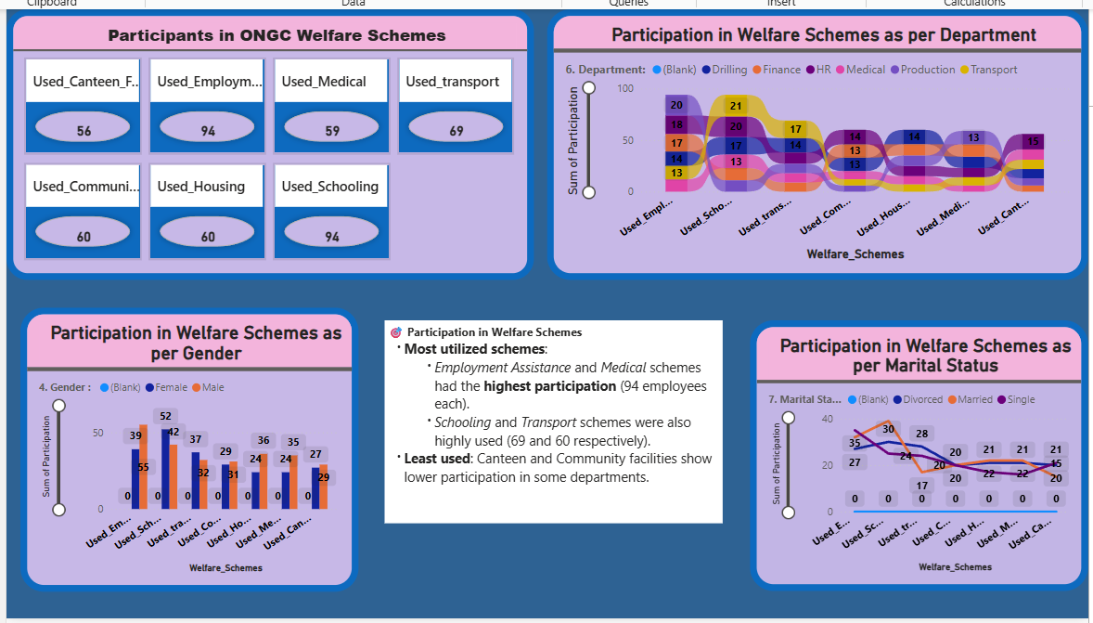

**Participants in ONGC Welfare Schemes**

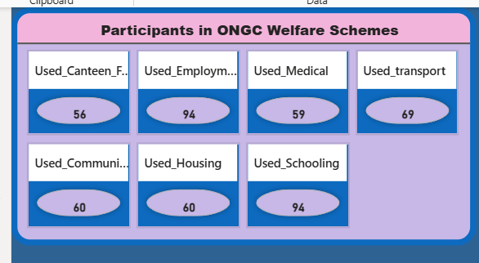

**Participation in Welfare Schemes as per Department**

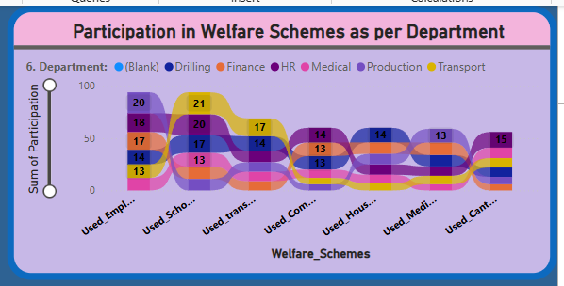

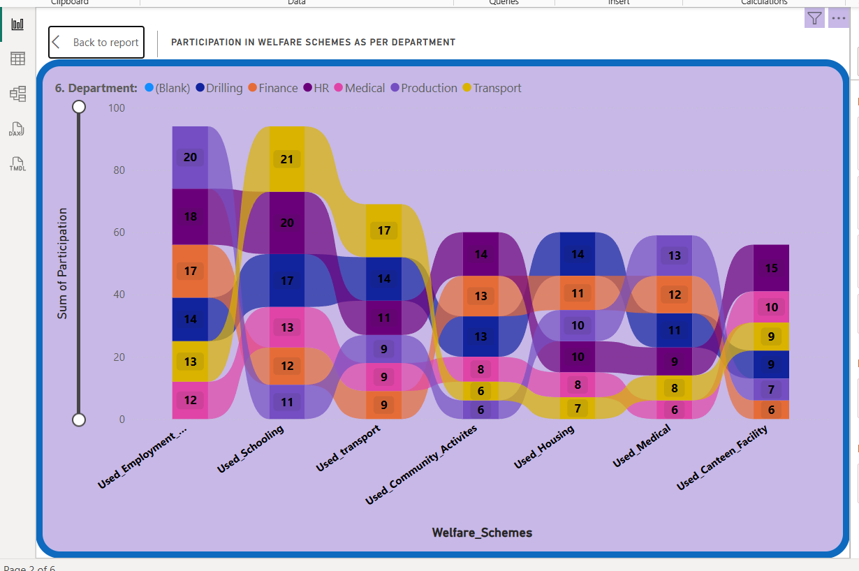

**Participation in Welfare Schemes as per Marital Status**

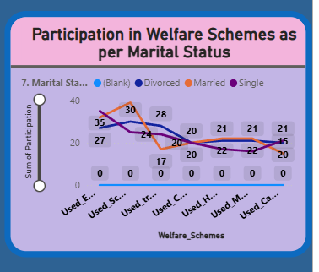 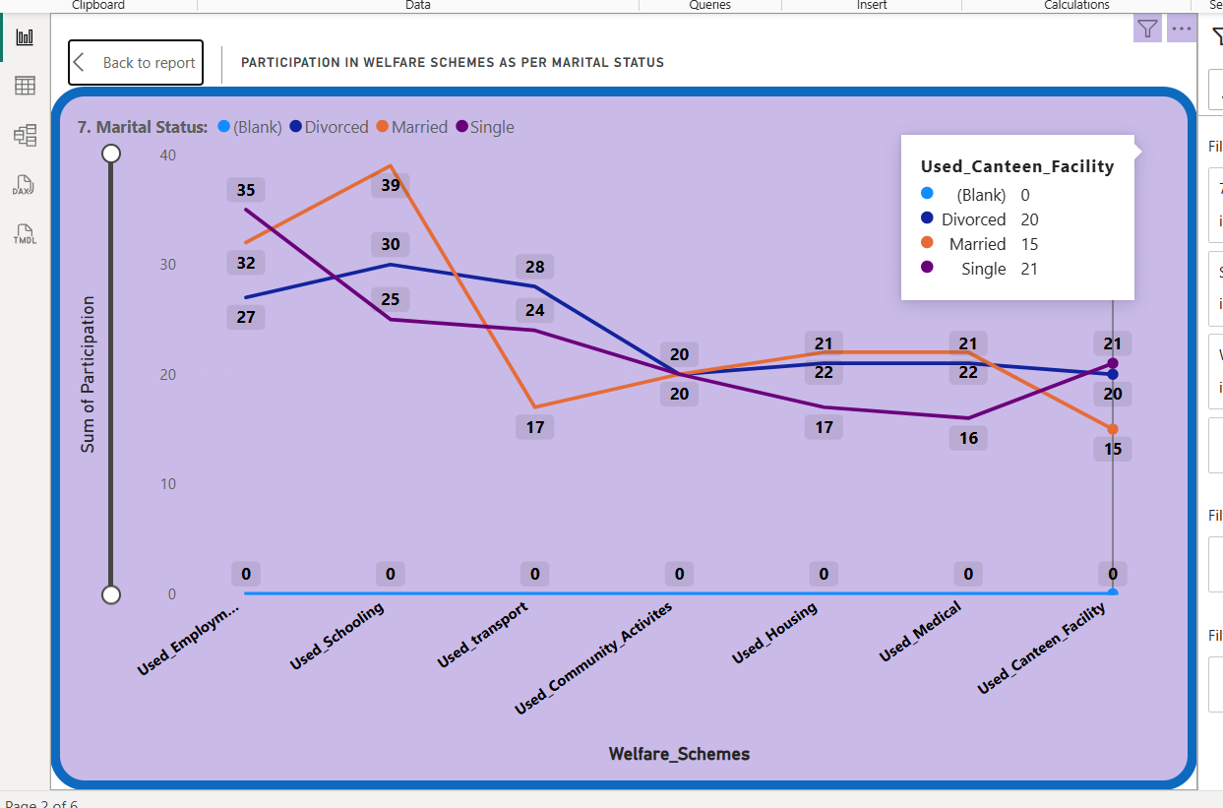

**Participation in Welfare Schemes as per Gender**

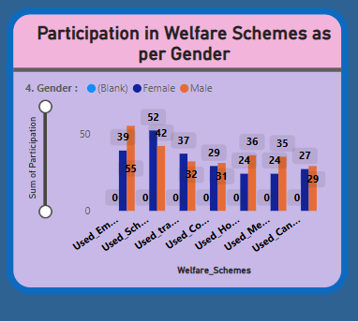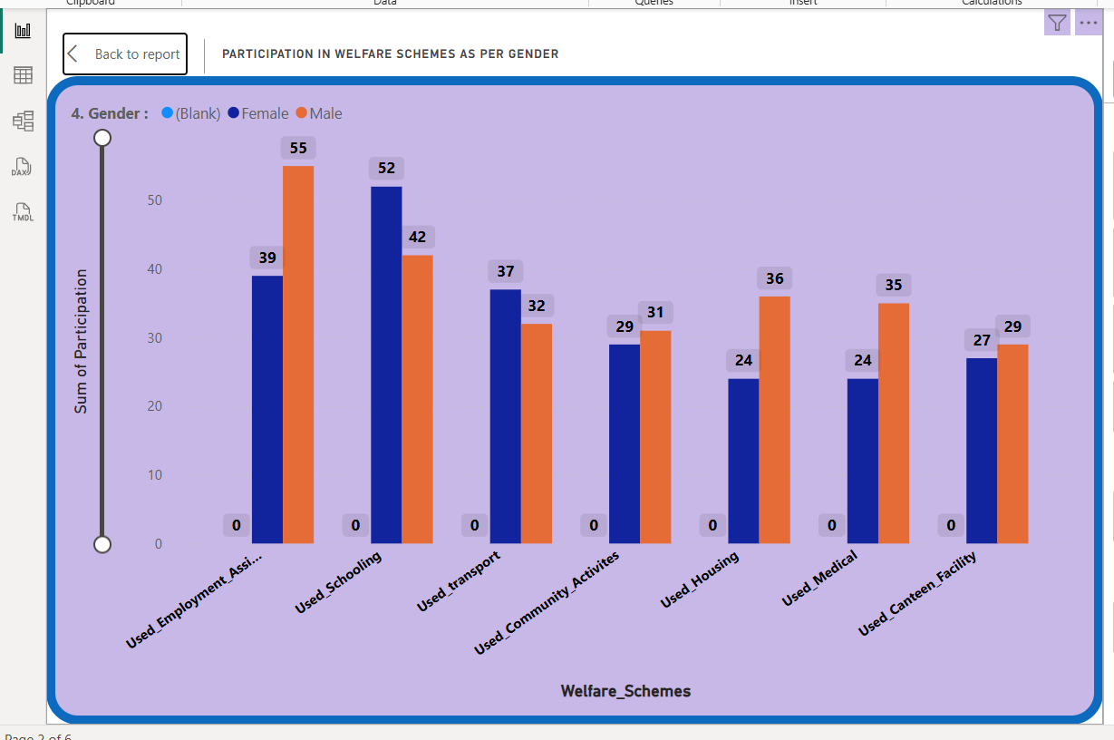

**Analysis of Participation Analysis**

**1. Participants in ONGC Welfare Schemes (Top Left Cards)**

* Highest Participation:
  + *Employment Assistance* – 94 employees
  + *Schooling* – 94 employees
* Moderately Used:
  + *Transport* – 69 employees
  + *Housing* – 60 employees
  + *Community Facilities* – 60 employees
  + *Medical* – 59 employees
* Lowest Participation:
  + *Canteen Facilities* – 56 employees

**Insight: Education-related and employment-related schemes are most valued, whereas canteen facilities have the least traction.**

**2. Participation in Welfare Schemes as per Department (Top Right Sankey Chart)**

* Employment Assistance – Highest uptake across multiple departments, especially *Finance* (21) and *Medical* (20).
* Schooling – Popular in *Drilling* (21) and *HR* (17).
* Transport – Strong in *Production* (17) and *Finance* (14).
* Other schemes such as *Community Facilities*, *Housing*, and *Canteen* show moderate but balanced participation across departments.

**Insight: Scheme preferences vary by department — HR and Finance tend to utilize educational and employment schemes more, while Production prefers transport benefits.**

**3. Participation in Welfare Schemes as per Gender (Bottom Left Bar Chart)**

* Employment Assistance: 55 males, 39 females
* Schooling: 52 males, 37 females
* Transport: 32 males, 29 females
* Housing: 36 males, 24 females
* Medical: 35 males, 29 females
* Canteen: 27 males, 29 females

**Insight: Male employees generally participate more in most schemes except *Canteen Facilities*, where female participation is slightly higher**.

**4. Participation in Welfare Schemes as per Marital Status (Bottom Right Line Chart)**

* Married employees have the highest participation across all schemes.
* Single employees participate less in housing and community-related schemes but use *Schooling* and *Employment Assistance* more.
* Divorced employees have minimal representation across all schemes.

**Insight: Marital status significantly affects welfare usage patterns — married employees prioritize stability-focused benefits like housing, schooling, and medical support.**

**5. Provided Text Box Insights (Center)**

* Most Utilized Schemes:
  + Employment Assistance & Schooling – 94 participants each
  + Transport – 69 participants
  + Housing & Community Facilities – 60 each
* Least Utilized Schemes:
  + Canteen Facilities – 56 participants
* Departmental Variation: Certain schemes (e.g., Canteen, Community Facilities) show lower participation in specific departments.

**Key Takeaways**

1. **Top Schemes:** Employment Assistance and Schooling dominate usage, indicating employees value career and education support.
2. **Gender Gap:** Males participate more in most schemes, suggesting a need to tailor certain benefits to encourage more female engagement.
3. **Marital Status Influence:** Married employees drive the highest participation, while singles focus on skill and education benefits.
4. **Departmental Focus:** Departments have unique preferences, meaning targeted welfare communication could improve uptake.
5. **Underused Benefits:** Canteen facilities and some community-based benefits may require revamping or better awareness campaigns.
6. **Demographic Analysis**

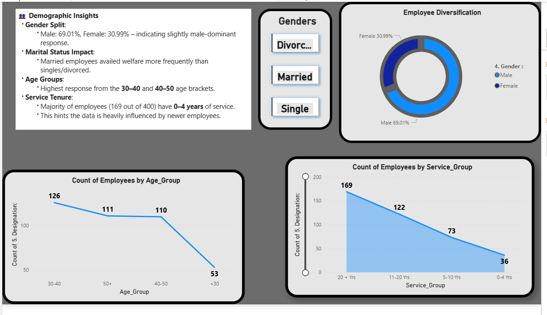

**Employee Diversification**

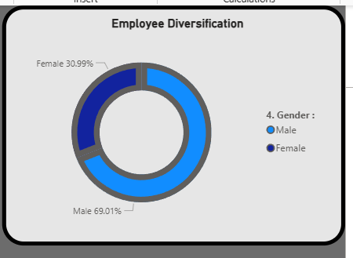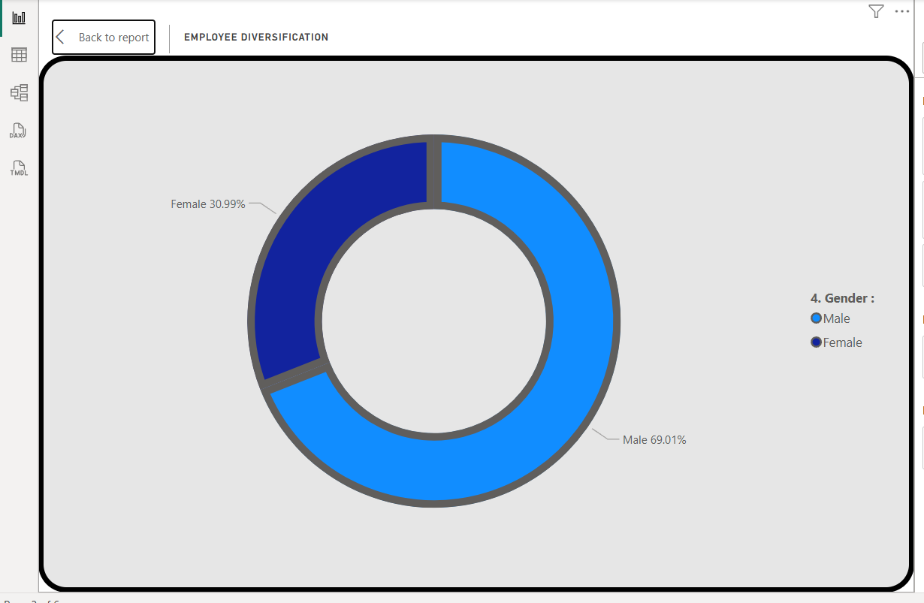

**Count of Employees by Service_Group**

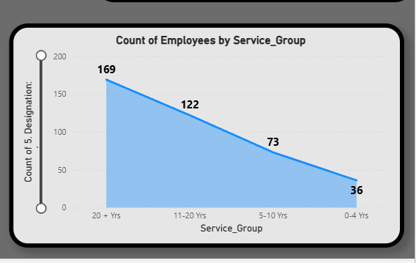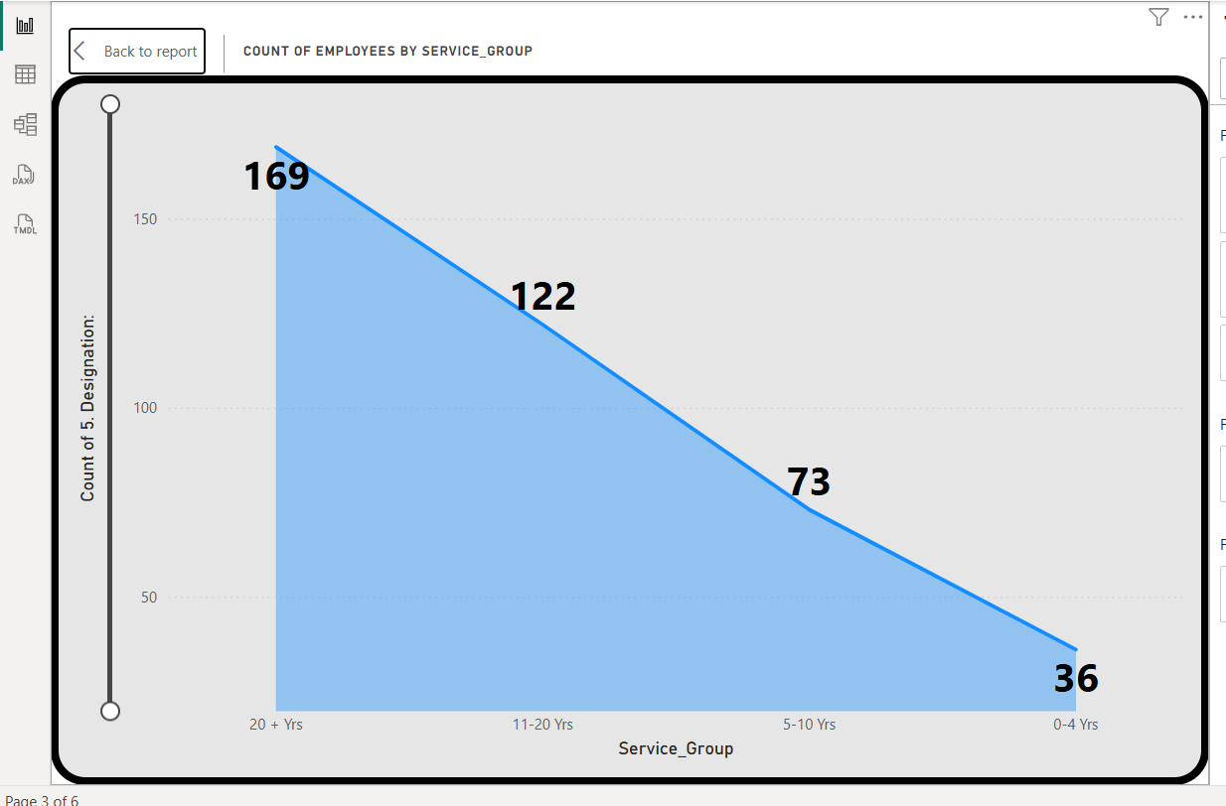

**Count of Employees by Age_Group**

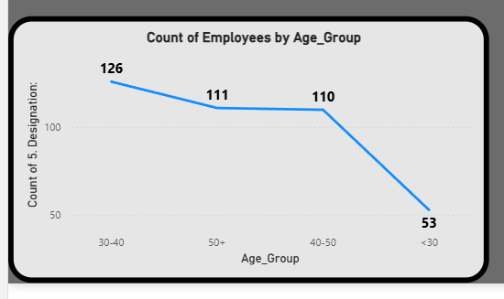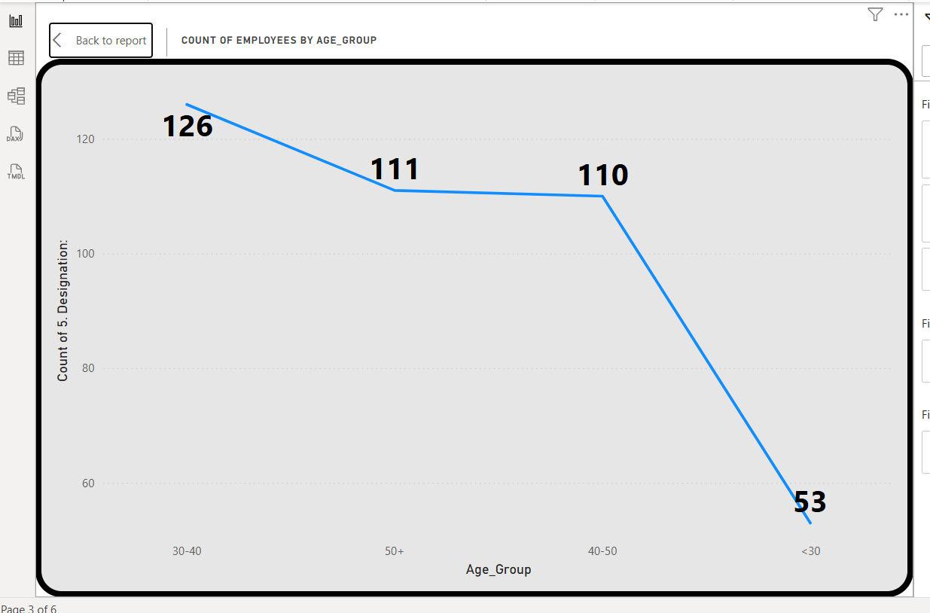

**Analysis of Demographic Analysis**

1. Demographic Insights (Text Box Summary)

* Gender Split:
  + Male: 69.01%
  + Female: 30.99%
  + This reflects a clearly male-dominated workforce.
* Marital Status Impact:
  + Married employees utilize welfare schemes more frequently than singles or divorced employees.
* Age Groups:
  + Highest participation from 30–40 and 40–50 age brackets.
* Service Tenure:
  + A majority (169 out of 400) have 0–4 years of service.
  + This suggests data is significantly influenced by new hires rather than long-tenured staff.

**2. Employee Diversification (Donut Chart)**

* Male employees make up 69.01% of the workforce.
* Female employees make up 30.99%.
* Gender diversity is limited, indicating scope for inclusion initiatives.

**3. Count of Employees by Age Group (Bottom Left Line Chart)**

* 30–40 years: 126 employees (largest group)
* 50+ years: 111 employees
* 40–50 years: 110 employees
* <30 years: 53 employees (lowest)

**Insight: The workforce is predominantly mid-career to late-career, with fewer young entrants, possibly impacting long-term succession planning.**

**4. Count of Employees by Service Group (Bottom Right Area Chart)**

* 0–4 years: 169 employees (largest segment — likely due to recent hiring drives)
* 11–20 years: 122 employees
* 5–10 years: 73 employees
* 20+ years: 36 employees (lowest)

**Insight: While there is a strong influx of newer employees, the drop in employees with 20+ years tenure could indicate upcoming retirements or reduced retention over long careers.**

**Key Takeaways**

1. **Gender Diversity Gap:** Over two-thirds of the workforce is male, requiring diversity initiatives.
2. **Marital Status Influence:** Married employees show higher engagement in welfare schemes — **single/divorced** employees **may require different engagement strategies.**
3. **Mid-to-Late Career Dominance:** Majority are 30+ years old, with fewer young professionals (<30), which could challenge future leadership pipelines.
4. **High Proportion of New Hires:** 0–4 year service group dominates, which could bring fresh perspectives but also challenges in retention and integration

**3.Performance Analysis**

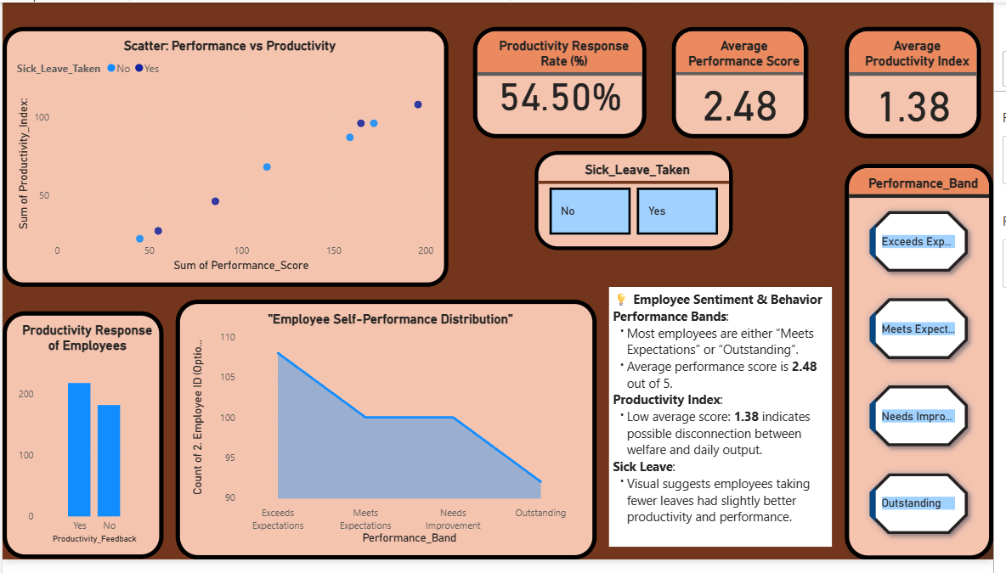

**Key Performance Indicators**

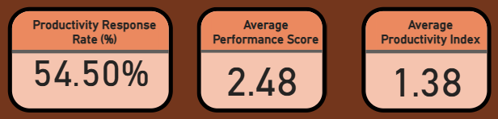

**Slicers**

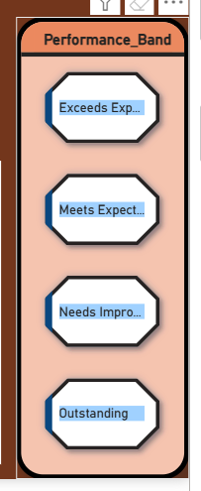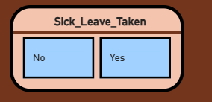

**Employee Self-Performance Distribution**

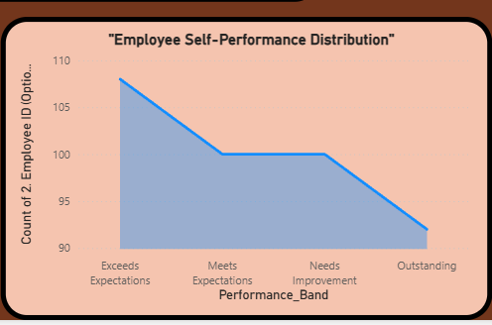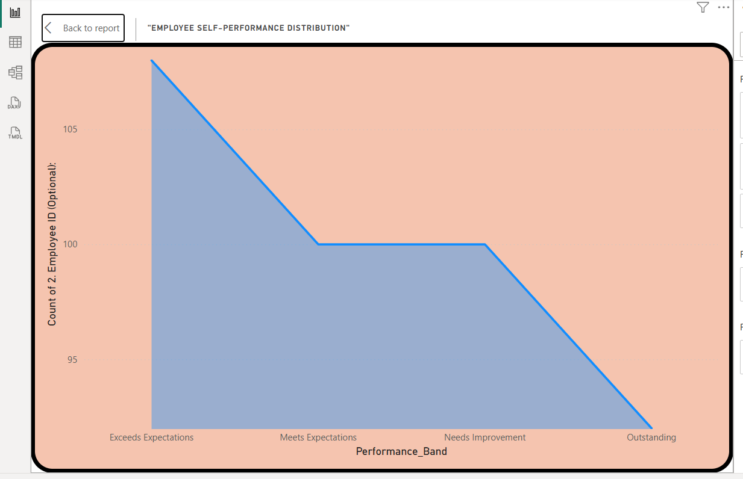

**Productivity Response of Employees**

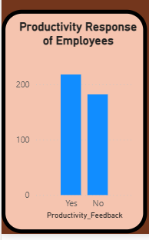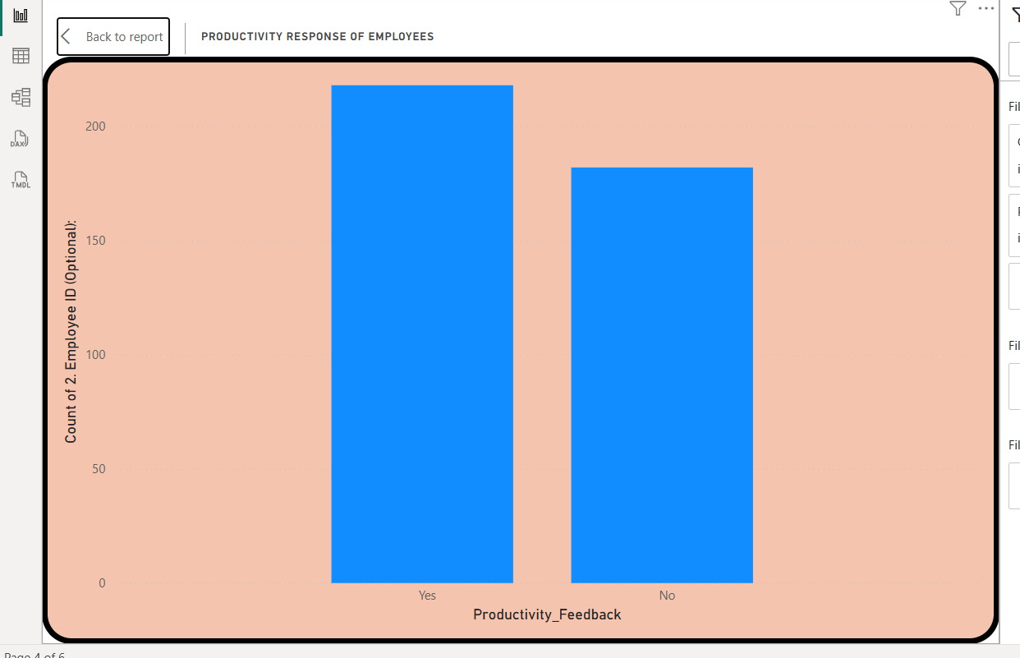

**Scatter: Performance vs Productivity**

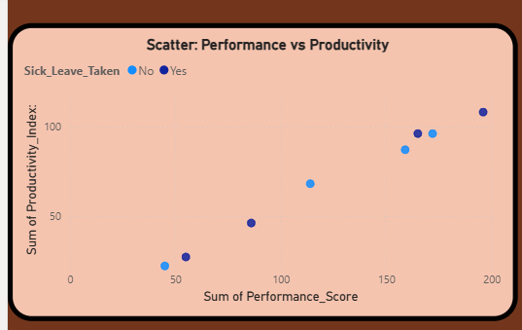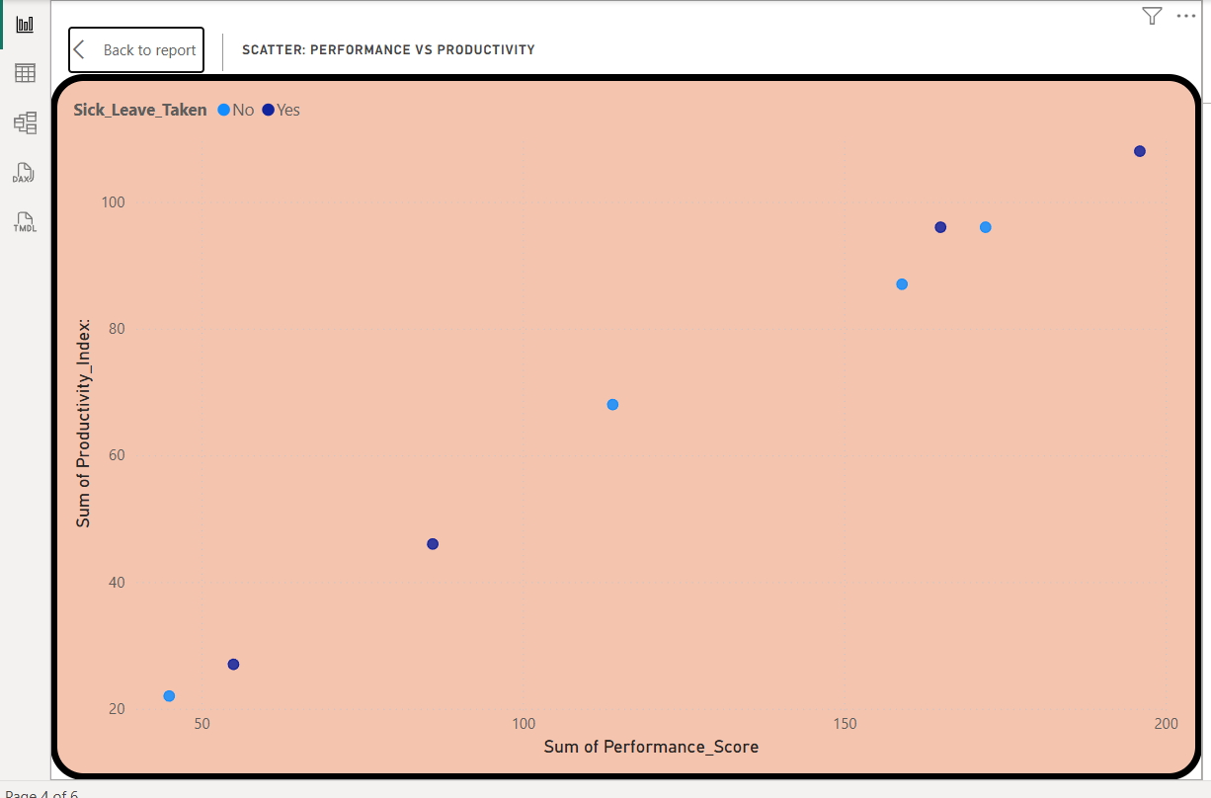

**Analysis of Performance Analysis**

**Scatter Plot: Performance vs Productivity**

* The scatter plot shows an inverse relationship between sick leave taken and productivity/performance
* Employees who took no sick leave (blue) show:
  + Higher productivity index scores (sum around 100-150)
  + Better performance scores (around 100-110)
* Employees who took sick leave (orange) show:
  + Lower productivity (sum around 50)
  + Lower performance scores (90-100)
* **This suggests presenteeism may be impacting results, where employees coming to work while unwell perform worse**

**Productivity Response Metrics**

* The overall productivity response rate is 54.5%, indicating only about half of employees are meeting expected productivity levels
* Average Performance Score is 2.48/5, which falls between "Meets Expectations" and "Needs Improvement"
* Average Productivity Index is very low at 1.38, suggesting significant room for improvement in daily output

**Performance Band Distribution**

* Most employees fall into either "Meets Expectations" or "Outstanding" categories
* The "Exceeds Expectations" and "Needs Improvement" bands have fewer employees
* This creates a bimodal distribution rather than a normal bell curve, indicating potential polarization in workforce performance

**Key Findings & Recommendations**

1. **Sick Leave Impact:** Employees taking fewer sick days show better metrics, but this may indicate they're working while unwell. Consider:
   * Better sick leave policies to support recovery
   * Presenteeism awareness programs
2. **Productivity Disconnect**: The low 1.38 productivity index suggests:
   * Potential misalignment between employee welfare and output expectations
   * Need for productivity training or workflow improvements
3. **Performance Polarization:** The bimodal distribution shows:
   * Some high performers ("Outstanding") and many average performers ("Meets Expectations")
   * Opportunity to raise overall performance through targeted development programs
4. **Response Rate Concern:** With only 54.5% productivity response rate:
   * Investigate engagement issues
   * Consider incentives or support for underperforming teams

**The dashboard reveals a workforce with untapped potential where supporting employee health and addressing productivity barriers could yield significant performance improvements.**

**4.** **Retention and Attrition Analysis**

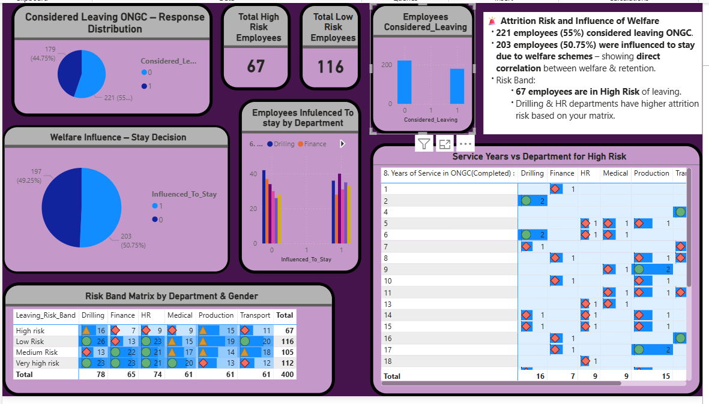

**KPI**

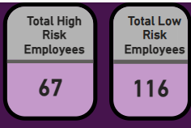

**Welfare Influence – Stay Decision**

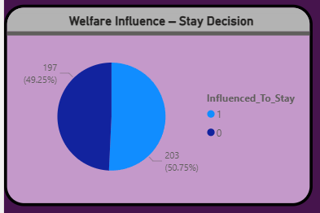

**Employees Infulenced To stay by Department**

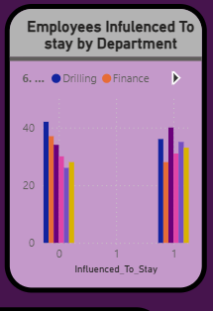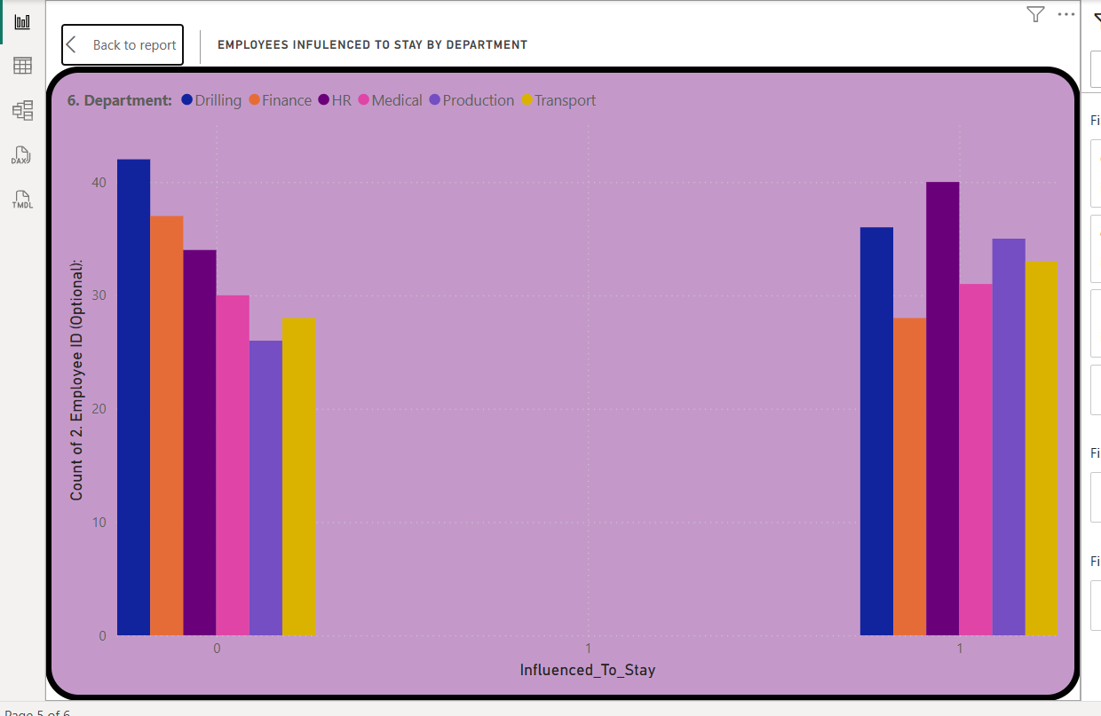

**Considered Leaving ONGC – Response Distribution**

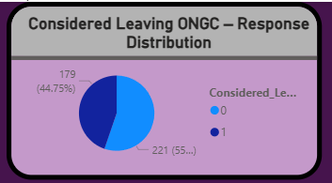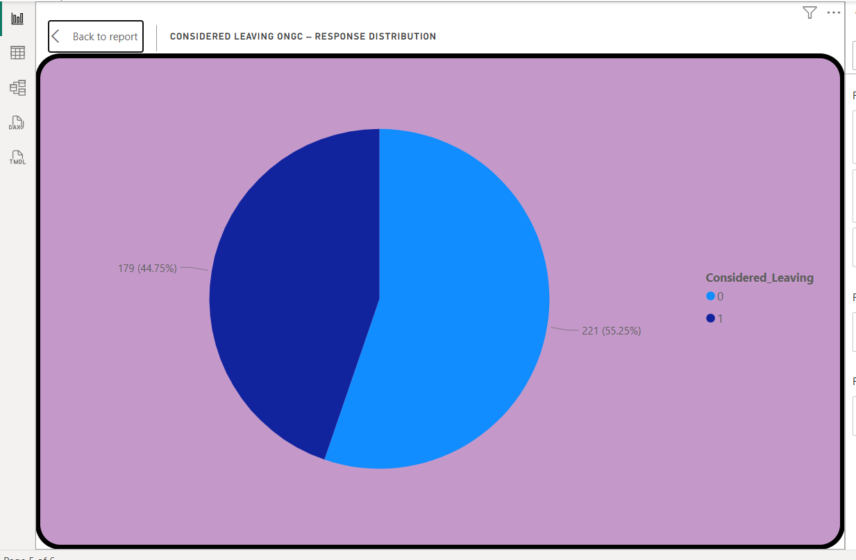

**Risk Band Matrix by Department & Gender**

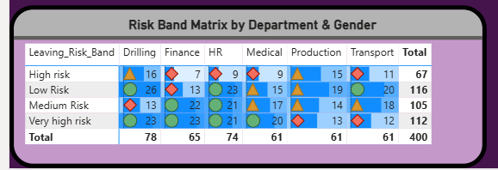

**Service Years vs Department for High Risk**

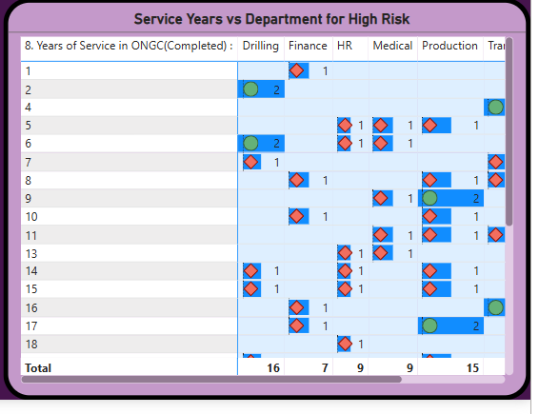

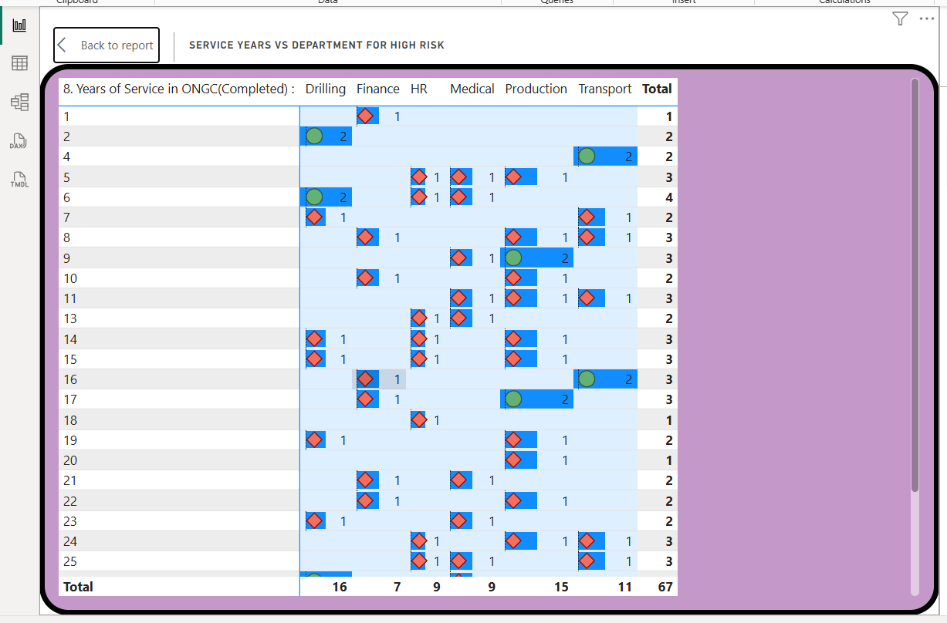

**Analysis of Employee Attrition & Welfare Influence**

**Overall Attrition Risk**

* **High Churn Consideration:** A significant portion of the workforce, **221 employees (55.25%)**, have considered leaving ONGC. This indicates a widespread retention challenge across the organization.
* **Identified High-Risk Cohort:** A specific group of **67 employees** has been classified as "High Risk" of leaving, representing the most immediate flight risk that requires urgent attention.

**Welfare Influence on Retention**

* **Positive Impact of Welfare:** Welfare schemes are a powerful retention tool. Of those who considered leaving, **203 employees (50.75%)** were influenced to stay specifically because of these schemes.
* **50/50 Effectiveness:** While effective, the influence is not universal. The near 50-50 split between those "Influenced To Stay" (203) and those not (197) suggests that while welfare is a crucial factor, it may not be sufficient on its own or its benefits may not be resonating with half of the at-risk employees.
* **Departmental Impact:** The **Drilling and Finance** departments show the highest number of employees who were positively influenced by welfare programs to reconsider leaving.

**Risk Distribution by Department & Tenure**

* **Risk Band Matrix by Department:**
  + The **Drilling** department is a major hotspot with the highest number of employees in both the "High Risk" (26) and "Very High Risk" (22) categories.
  + **HR, Production, and Transport** also show significant numbers of "High Risk" employees, indicating that the retention issue is not isolated to a single function.
* **Service Years Analysis (for High-Risk Employees):**
  + Attrition risk is not limited to new hires. There is a significant concentration of high-risk employees in the **mid-career (5-10 years)** bracket across multiple departments (especially Drilling and HR). Losing these employees means losing valuable institutional knowledge and experience.
  + The **Production** department exhibits a unique challenge, with a cluster of high-risk employees in the **senior tenure bracket (15-18 years)**.

**Key Findings & Recommendations**

* **Finding 1: Critical Attrition Vulnerability:** Over half the workforce has considered leaving. This is a systemic issue, not just a series of isolated cases.
  + **Recommendation:** Launch a company-wide employee engagement survey to understand the root causes beyond welfare, focusing on factors like career growth, management, and work-life balance.
* **Finding 2: Welfare Schemes are a Double-Edged Sword:** They are successfully retaining half of the at-risk employees but failing to influence the other half.
  + **Recommendation:** Deepen the analysis of welfare schemes. Conduct focus groups with both the "influenced" and "not influenced" groups to identify which specific benefits are most effective and where the gaps lie. Tailor or communicate benefits differently for high-risk departments.
* **Finding 3: Department-Specific Crises:** Drilling is the most critical department, followed by HR, Production, and Transport.
  + **Recommendation:** Implement targeted intervention plans for these departments. For **Drilling**, this may involve reviewing work conditions, shift patterns, or management support. For **HR**, it could relate to workload or career development opportunities within the function itself.
* **Finding 4: Key Career Points are Vulnerable:** The loss of mid-career professionals and senior-tenured staff in Production poses a significant threat to operational continuity and expertise.
  + **Recommendation:** Develop distinct retention strategies for different tenure bands. Introduce clear career progression and development plans for mid-career employees. For senior employees, especially in **Production**, explore mentorship roles, specialized project leadership, or knowledge transfer incentives to keep them engaged.

**The dashboard clearly indicates that while welfare initiatives provide a foundational level of retention, a more targeted, department- and tenure-specific strategy is necessary to mitigate the high attrition risk prevalent at ONGC.**

**5.Cost VS Benefit Analysis**

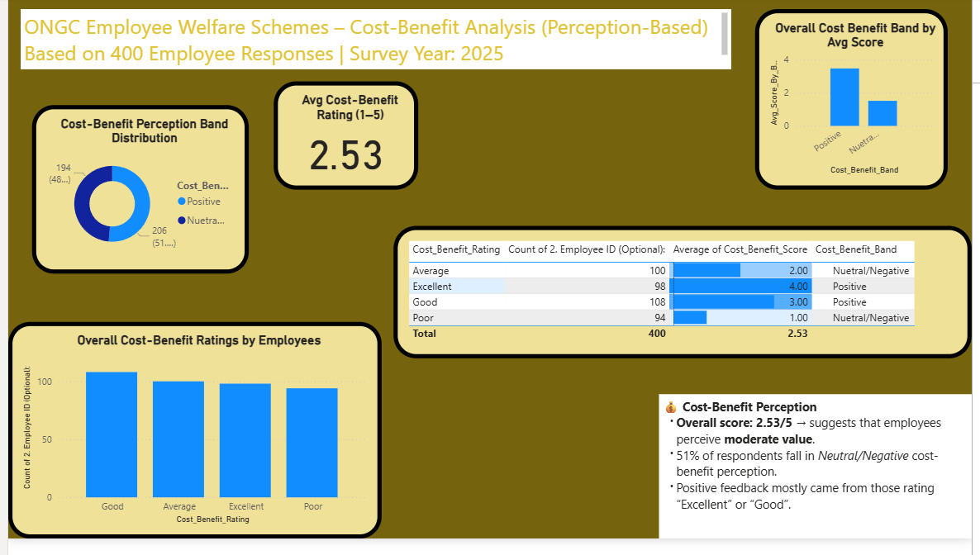

**KPI**

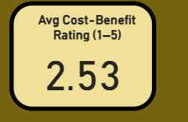

**Overall Cost Benefit Band by Avg Score**

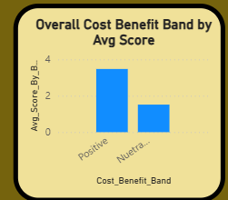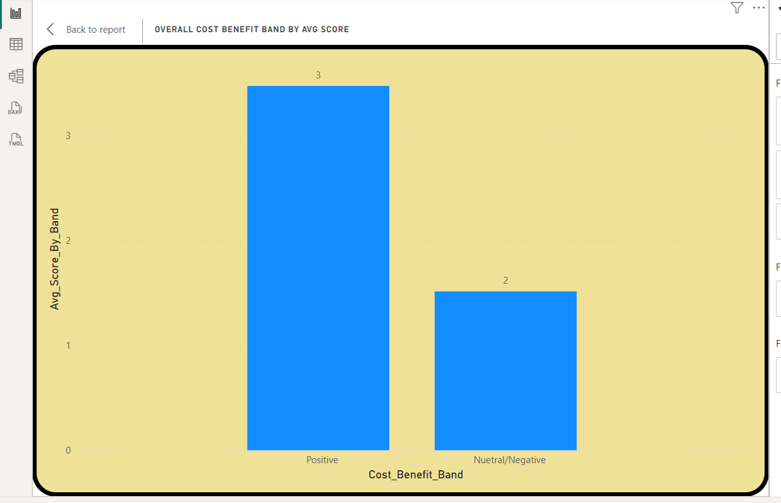

**Cost-Benefit Perception Band Distribution**

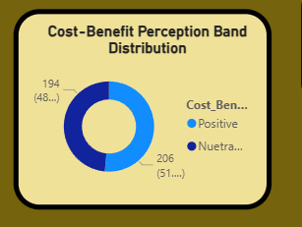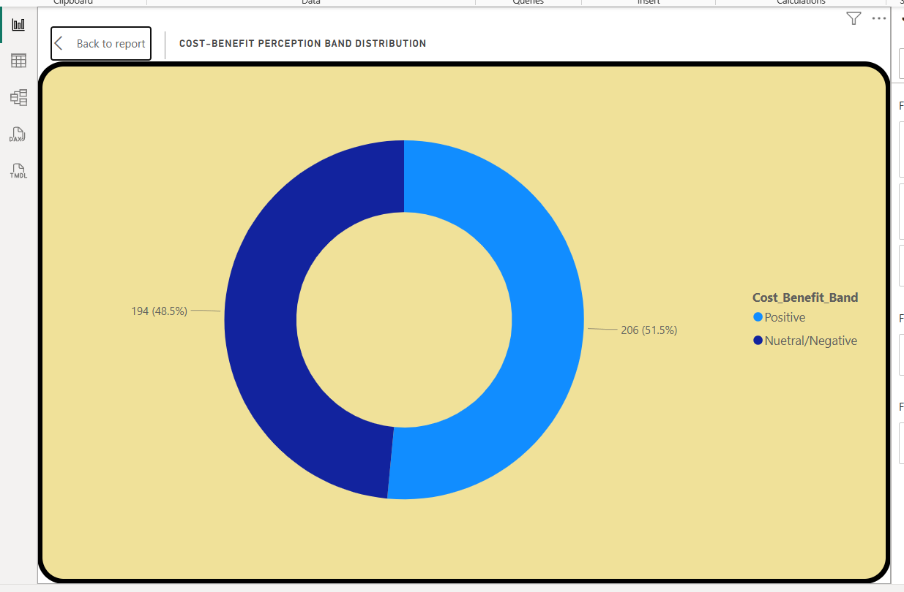

**Overall Cost-Benefit Ratings by Employees**

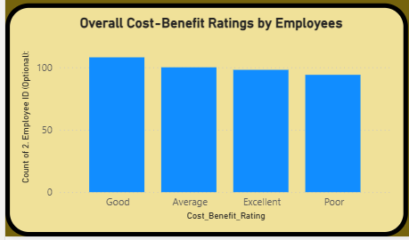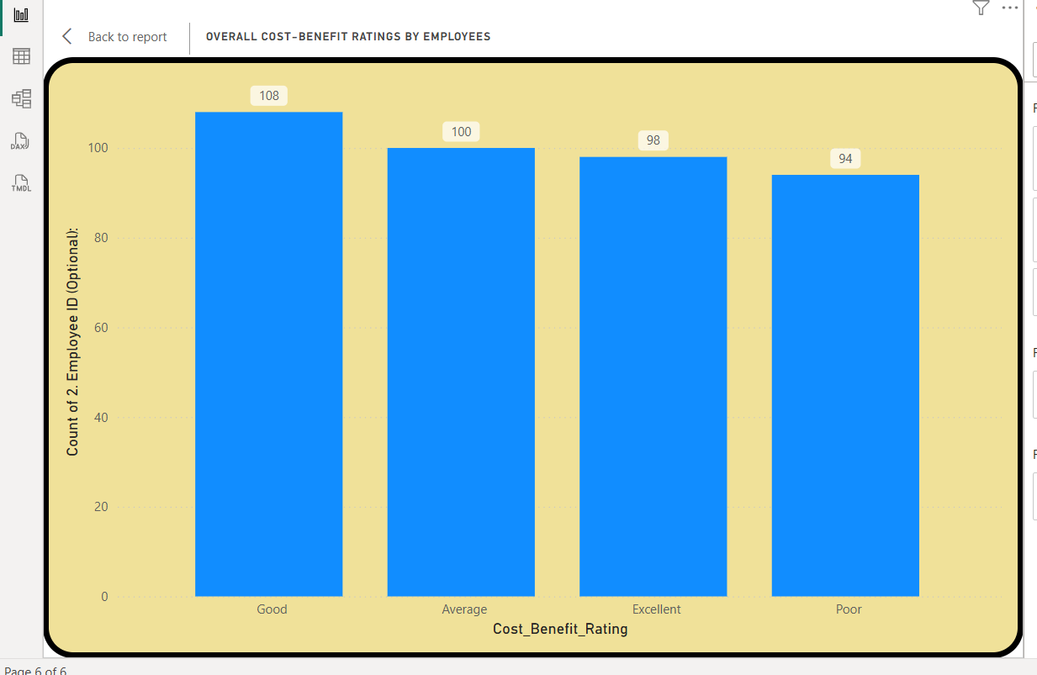

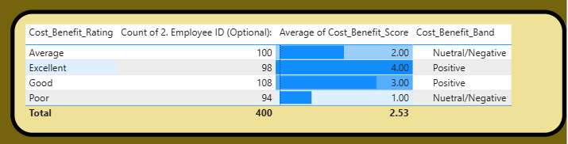

**Analysis of Welfare Schemes Cost-Benefit Perception**

**Overall Perception & Sentiment**

* **Mediocre Value Perception:** The average cost-benefit rating for ONGC's welfare schemes is a lackluster 2.53 out of 5. This score sits barely above the midpoint, indicating that, on average, employees perceive only moderate value from the benefits provided.
* **Negative Sentiment Prevails**: A slight majority of the workforce, 206 employees (51.5%), fall into the "Neutral/Negative" perception band. This means more than half of the employees do not see a positive return or value from the welfare programs offered.

**Distribution of Employee Ratings**

* **Polarized Employee Feedback:** The responses are spread almost evenly across all four categories ("Good," "Average," "Excellent," and "Poor"). There is no strong positive skew.
* **Significant Dissatisfaction:** Critically, the number of employees who rated the schemes as "Poor" (94) is nearly as high as those who rated them "Excellent" (98). This indicates a deeply divided workforce, where a substantial group feels the welfare schemes offer very little value, effectively canceling out the positive sentiment from others.

**Connection to Attrition Insights**

* **Explaining Retention Gaps:** This dashboard provides a clear reason for the findings in the previous attrition analysis. The previous dashboard showed that welfare schemes failed to influence nearly half of the at-risk employees to stay.
* **Low Value Equals Low Impact**: The 51.5% of employees with a "Neutral/Negative" perception of cost-benefit are very likely the same group that was not influenced to stay. The low perceived value of the welfare package directly undermines its power as a retention tool.

**Key Findings & Strategic Recommendations**

* **Finding 1: Underwhelming Return on Investment**: The 2.53/5 score is a strong indicator that the current investment in welfare schemes is not delivering a high perceived value to employees. The programs are seen as average at best.
* **Finding 2: A "One-Size-Fits-All" Approach is Failing**: The polarized ratings suggest that the current welfare package does not cater to the diverse needs of the workforce. What works for some is clearly not working for others**.**
* **Finding 3:** Poor Perception is a Direct Attrition Driver: The failure to demonstrate clear value from welfare schemes is a significant factor in employees considering departure. When benefits feel inadequate, they cease to be a reason to stay.

**This analysis reveals that the welfare schemes, a key pillar of ONGC's retention strategy, are underperforming due to a crisis of perceived value, which directly contributes to the attrition risks identified previously.**

**How This Project Provides Valuable Insights for ONGC**

This project is much more than a collection of charts; it's a strategic tool that provides actionable intelligence for ONGC's management and HR department.

* **It Pinpoints Exact Problem Areas:** Instead of a vague sense of employee dissatisfaction, your dashboard gives management precise targets. The low scores for the Children Education Allowance and Canteen Facility are not just numbers; they are clear mandates for review and reform. This data-driven approach allows for the efficient allocation of resources to areas that matter most to employees.
* **It Explains the "Why":** The project's greatest strength is that it connects the "what" (low satisfaction scores) with the "who" (the demographic profile). It explains *why* certain policies are underperforming—because they are failing to meet the needs of the young, family-oriented majority. This insight prevents guesswork and allows for the development of policies that are relevant to the current workforce.
* **It Provides a Baseline for Future Measurement:** This analysis establishes a clear benchmark for employee satisfaction. After implementing changes, ONGC can conduct a follow-up survey and use this dashboard to measure the impact of its initiatives. For example, a successful revision of the education allowance should directly translate to an increased satisfaction score in a future analysis.

**CHAPTER 5**

**RECOMMENDATIONS**

Based on the detailed analysis of survey data from 400 ONGC employees, the following recommendations are proposed to optimize the existing employee welfare schemes, improve employee satisfaction, and enhance retention. The recommendations are data-driven and address the key problem areas identified in the study, including attrition risk, mediocre value perception of schemes, departmental disparities, and low productivity.

**1. Strategic Recommendations to Address Attrition and Value Perception**

The study reveals a critical retention challenge, with

55.25% of employees having considered leaving and

67 employees classified as "High Risk". This is compounded by a mediocre

average cost-benefit score of 2.53/5 for welfare schemes.

* **Implement Targeted Retention Programs for High-Risk Departments:**
  + **Recommendation:** Immediately launch targeted intervention plans for the Drilling and HR departments, which show the highest attrition risk.
  + **Action Steps:** Conduct departmental focus groups to identify specific pain points. Review work conditions, management support, and career progression opportunities unique to these departments.
* **Enhance the Perceived Value of Welfare Schemes:**
  + **Recommendation:** Address the polarized feedback where nearly half the workforce rates the schemes as "Average" or "Poor". The goal is to move the 2.53/5 score upwards by aligning benefits with employee needs.
  + **Action Steps:** Conduct "pulse surveys" to dig deeper into *why* certain benefits are perceived as low value. Use this feedback to either phase out unpopular schemes or redesign them to be more relevant.

**2. Tactical Recommendations for Specific Welfare Schemes**

The participation data shows clear preferences, with some schemes being highly valued and others underutilized.

* **Strengthen and Promote High-Usage Schemes:**
  + **Recommendation:** Capitalize on the popularity of the Employment Assistance and Schooling schemes, which had the highest participation with 94 employees each.
  + **Action Steps**: Expand the scope of these schemes. For schooling, consider partnerships with more educational institutions or offering scholarships. For employment assistance, provide career counseling services for employees' dependents.
* **Overhaul and Modernize Underperforming Schemes:**
  + **Recommendation:** Revamp the Canteen Facilities, which recorded the lowest participation among all schemes (56 employees).
  + **Action Steps:** Conduct a vendor review, introduce more diverse and healthier menu options, and implement a digital feedback system for real-time quality control.

**3. Demographic-Targeted Initiatives for a Diverse Workforce**

The analysis highlights that welfare scheme usage varies significantly based on marital status, gender, and age. A one-size-fits-all approach is failing.

* **Develop Family-Centric and Youth-Oriented Benefits:**
  + **Recommendation:** Acknowledge that married employees are the most frequent users of welfare and that the workforce is dominated by the

30-40 age group.

* + **Action Steps**: Introduce benefits tailored to these groups, such as enhanced parental support, flexible working hours for parents, and workshops on financial planning for families. For the large cohort of new hires (0-4 years), create an onboarding package focused on career development and skill-building loans.
* **Promote Gender Inclusion through Tailored Schemes:**
  + **Recommendation:** Address the gender imbalance in the workforce (69.01% Male) and the lower participation of women in most schemes.
  + **Action Steps:** Review existing benefits to ensure they are equally accessible and appealing to female employees. Introduce and actively promote initiatives like mentorship programs for women, leadership development tracks, and enhanced childcare/crèche facilities.

**4. Enhancing Productivity and Employee Well-being**

The study identified a low Average Productivity Index of 1.38 and a potential disconnect between welfare and daily output.

* **Integrate Wellness Programs with Performance Goals:**
  + **Recommendation:** Bridge the gap between employee well-being and productivity.
  + **Action Steps:** Launch wellness initiatives focused on mental health, stress management, and physical fitness. Provide resources like counseling services and ergonomic support to create a healthier, more focused, and productive work environment.
* **Revise Sick Leave Policies to Encourage Genuine Recovery:**
  + **Recommendation:** The data suggests employees who take fewer sick days perform better, hinting at a potential issue of presenteeism (working while unwell)**.**
  + **Action Steps:** Promote a culture where employees are encouraged to take necessary time off to recover fully. Review sick leave policies to ensure they are supportive and non-punitive, thereby improving long-term health and productivity.

**CHAPTER 6**

**CONCLUSION**

This research project was initiated to conduct a granular, data-driven analysis of the employee welfare schemes at Oil and Natural Gas Corporation (ONGC), with the primary objective of evaluating their true effectiveness as a tool for employee retention and satisfaction. By leveraging business analytics and interpreting survey responses from 400 employees, this study has successfully moved beyond generalized assumptions to uncover specific, actionable insights. The findings present a multi-faceted narrative, revealing a significant disconnect between the extensive welfare infrastructure provided by ONGC and its real-world impact on a diverse and evolving workforce. The core conclusion is that while ONGC's commitment to employee welfare is evident, its current strategy yields a suboptimal return on investment, failing to universally secure employee loyalty or address underlying issues of attrition and productivity.

The most critical finding is the stark reality of the retention challenge at ONGC. Despite a reputation for long-term employment, the data reveals a significant vulnerability, with a majority of

**221 employees (55.25%) having considered leaving the organization**. This sentiment is not uniform; the analysis pinpoints specific high-risk zones, identifying

**67 employees as immediate flight risks** and highlighting the

**Drilling and HR departments as departmental hotspots for attrition**. Furthermore, the risk is concentrated at critical career stages, particularly among experienced mid-career professionals (5-10 years) and senior employees in the Production department. This is compounded by the central paradox of the study: welfare schemes act as a retention lever for only half of the at-risk workforce, with

**203 employees (50.75%) being influenced to stay**, while the remaining **197 employees (49.25%) remain unpersuaded**. This 50/50 split demonstrates that the welfare package, in its current form, is not a sufficiently powerful or universally appealing anchor.

The reason for this limited impact is clearly explained by the cost-benefit perception analysis.

The **average cost-benefit score of 2.53 out of 5** confirms that employees, on average, perceive only moderate value from the schemes. A slight majority of

**206 respondents (51.5%) fall into a "Neutral/Negative" perception band**. Digging deeper, the feedback is highly polarized, with the number of employees rating the schemes as "Poor" (94) being nearly equal to those rating them "Excellent" (98). This confirms that a standardized, "one-size-fits-all" welfare strategy is obsolete and is failing to resonate with a significant portion of the workforce, thereby weakening its potential as a retention tool.

This disconnect has ripple effects on broader organizational health, particularly on productivity. The study uncovered a very low

**Average Productivity Index of 1.38** , with the analysis explicitly suggesting a "possible disconnection between welfare and daily output". The correlation between sick leave and lower performance further suggests that the current welfare model may not be adequately fostering the holistic well-being required for optimal engagement at work. The participation data reinforces this narrative of shifting priorities; employees show the highest engagement with career- and family-oriented benefits like

**Employment Assistance and Schooling (94 participants each)** , while foundational amenities like

**Canteen Facilities see the lowest usage (56 participants)**. This indicates a clear preference for schemes that support long-term personal and professional growth over basic workplace conveniences.

In synthesizing these findings, this project concludes that ONGC's path forward lies in strategic optimization, guided by the analytical insights unearthed. The data paints a clear picture of the modern ONGC employee: the workforce is heavily influenced by a large cohort of newer hires with

**0-4 years of service** , predominantly in the **30-40 age bracket** , and largely composed of

**married individuals** whose needs are specific and value-driven. By embracing a targeted, segmented, and data-informed approach, ONGC can transform its welfare program from a passive, high-cost expenditure into a dynamic and efficient strategic asset. This evolution is essential not only to mitigate the clear and present danger of attrition but also to proactively build a resilient, motivated, and highly productive workforce, thereby cementing ONGC’s status as a premier employer in the competitive energy sector for years to come.

|  |
| --- |
| • 1. Core Finding: An Opportunity to Enhance the Value of Welfare Schemes |
| This project concludes that ONGC has a significant opportunity to increase the return on its investment in employee welfare by aligning the schemes more closely with the specific needs and values of its workforce. The analysis provides a clear path to transform the existing, comprehensive welfare program into an even more effective strategic asset. |
| • 2. Strategic Focus on Talent Retention |
| The analysis offers valuable data for strategic retention efforts by highlighting that 55.25% of employees have considered leaving. This insight allows ONGC to proactively engage with its talented workforce, with a special focus on key departments such as Drilling and HR, which were identified as areas with a higher concentration of at-risk employees. |
| • 3. Building on the Success of Welfare as a Retention Tool |
| The welfare schemes are already a significant retention driver, successfully influencing over half (50.75%) of at-risk employees to stay. This strong foundation presents an opportunity to expand this positive influence to an even broader segment of the workforce by refining the benefits package. |
| • 4. A Clear Path to Elevate Employee Value Perception |
| The current average cost-benefit score of 2.53 out of 5 provides a useful baseline for future enhancements. By addressing the feedback from the 51.5% of employees who currently have a neutral or negative perception, ONGC can significantly boost overall satisfaction and morale. |
| • 5. Transitioning to a Customized, Needs-Based Approach |
| The diverse employee feedback, with nearly equal numbers rating the schemes as "Poor" (94) and "Excellent" (98), points to an opportunity to evolve from a standardized model to a more flexible and customized welfare strategy that better caters to the varied needs of the organization's dedicated employees. |
| • 6. Potential to Boost Productivity through Enhanced Well-being |
| The analysis suggests a strong link between holistic employee well-being and organizational productivity, which is currently indexed at 1.38. By further strengthening its wellness initiatives, ONGC can positively influence employee engagement, leading to enhanced daily output and overall performance. |
| •  7. Aligning Schemes with Core Employee Priorities |
| The participation data clearly shows that employees place high value on benefits supporting long-term growth and family needs, such as Employment Assistance and Schooling (94 participants each). This valuable insight allows ONGC to focus future investments on the schemes that matter most to its people. |
| 8. A Strategic, Data-Driven Roadmap for the Future |
| Ultimately, this project provides a clear, data-driven roadmap for ONGC to continue refining its world-class welfare strategy. The analysis empowers leadership to make informed decisions that cater to key workforce demographics, ensuring the welfare program becomes an even more powerful tool for fostering loyalty, enhancing talent retention, and securing ONGC's position as a premier employer. |

# BIBLIOGRAPHY

1. Core Functions of Human Resource Management and its Effectiveness on Organization: A Study (Vol.09) ; International Journal of Research in Economics and Social Sciences(IJRESS) by Parul Pattrick and Dr. Shabana Mazhar.
2. ONGC HR MANUAL.
3. ongcindia.com
4. Impact of employee welfare and benefits on employee retention (Vol. 04) August 2015, by Ankita Rathore, University of Rajasthan .
5. What is human resources? The ultimate guide by Dennis O'Reilly in Forbes Advisor newsletter.
6. Linkage of Employee Welfare Programs with Workforce Retention in Modern Organizational Management Policies by Oluwatosin ,Darmawan ,Marsal 2021
7. Teti, E., & Andriotto, M. (2013). Effectiveness of employee welfare schemes: differences of specific professional profiles. The International Journal of Human Resource Management, 24(17), 3232–3246. https://doi.org/10.1080/09585192.2013.763840
8. Internal documents: ONGC Office Order
9. 9 Ankita Rathore (2015)
10. As cited in the report, this study investigates how employee welfare and benefits affect retention, job satisfaction, and performance.
11. E Teti & M Androitto (2013)
12. As cited in the report, this research focuses on corporate social responsibility, highlighting employees as key stakeholders and analyzing benefit satisfaction based on surveys from a major multinational firm.
13. International Labour Organization (ILO)
14. As cited in the report, provided a definition of labour welfare as the range of services, facilities, and amenities made available to workers to enable them to perform their duties in safe, healthy, and pleasant conditions.
15. Labour Investigation Committee (1946)
16. As cited in the report, defined employee welfare to include all initiatives that contribute to the intellectual, physical, moral, and economic well-being of workers.
17. Oil and Natural Gas Corporation (ONGC)
18. *Annual Reports of ONGC*. Used as a source for organizational data, HR statistics, and policy changes.
19. *ONGC Human Resource Manual*. Used to understand the official employee welfare policies and frameworks.
20. Oluwatosin, Darmawan, Pedro Marsal (2021)
21. As cited in the report, this literature review explores the relationship between employee welfare initiatives and workforce retention, highlighting the role of a human-centered HR approach.
22. Parul Pattrick & Shabana Mazhar (2019)
23. As cited in the report, this research highlights that employees are strategic assets and that strong human resource management is required to face business challenges.

**Detailed Weekly Internship Summary**

**Week 1 (June 16th–20th): Project Initiation & Foundational Research**

The internship began with an orientation to understand ONGC's employee welfare policies and frameworks. Secondary research was conducted on existing schemes, and an outline for the employee survey questionnaire was drafted using MS Word and internal ONGC HR documents. The main challenge was aligning the internal policies with the project's analytical scope. Key learnings included interpreting welfare policies from an analytical perspective and understanding data privacy protocols.

**Week 2 (June 23rd–27th): Survey Development & Pilot Data Collection**

This week focused on finalizing the employee feedback survey using Google Forms and circulating it to selected departments for pilot responses. A key challenge was a low initial response rate, which required refining the outreach method. This led to learning about effective survey design, employee engagement techniques, and the behavioral insight that adjusting the tone and language of the survey can significantly increase the response rate.

**Week 3 (June 30th–July 04th): Data Collection & Preparation**

Approximately 100 employee responses were collected, and the process of data cleaning and categorization began. The primary tools used were MS Excel and Google Sheets. A significant challenge was identifying and handling inconsistent responses and duplicates within the dataset. This provided functional learning in data wrangling and managing real-world data inconsistencies.

**Week 4 (July 07th–11th): Trend Analysis & Initial Dashboard Development**

The focus shifted to analyzing key trends from the collected data, such as the most utilized schemes and satisfaction levels segmented by age group. The creation of visual dashboards was initiated using Power BI and Excel Pivot Tables. The main challenge was designing meaningful and non-redundant visuals. This week resulted in gaining proficiency in Power BI and learning to communicate statistical insights visually.

**Week 5 (July 14th–June 25th): Dashboard Finalization & Insight Generation**

The Power BI dashboard was finalized with segmented views for age, designation, and scheme usage. This analysis helped in identifying low-impact schemes and the potential reasons for their underperformance. A challenge was ensuring data anonymity in the shared dashboards. Learning outcomes included mastering dashboard filtering and interactivity and developing communication skills through interactions with HR heads for data context.

**Week 6 (July 28th– Aug 01st): Report Drafting & Visual Storytelling**

The structure of the final report was completed, covering the introduction, methodology, findings, and recommendations. Alongside the report, Canva was used to design infographics to summarize findings visually. The challenge was to convey the findings effectively without textual overload. This week emphasized the importance of visual storytelling and provided insight into the details that stakeholders prioritize.

**Week 7 (Aug 04th – 08th): Final Report & Presentation Compilation**

The final report was completed by incorporating mentor feedback. The final presentation deck was also created using PowerPoint and Canva, featuring key visuals from the analysis. The primary challenge was condensing two months of intensive work into a concise 6–8 slide presentation. Key learnings involved integrating critical feedback and mastering stakeholder storytelling through effective deck design.

**Week 8 (Aug 11th –15th): Project Presentation & Final Submission**

The internship concluded with the final presentation delivered at ONGC and the submission of all project documentation to both the company and the college. A challenge during this phase was time management during the live presentation. The final week's learning outcomes focused on understanding project closure protocols, the formal handoff process, and reflecting on the entire internship journey.

**Plagiarism Report**

This is to certify that the dissertation / project titled **“Optimizing Employee Welfare Schemes Using Business Analytics: A Case Study on ONGC (Dehradun Tel Bhawan)”** submitted by Abhishek Singh Rana in partial fulfillment of the requirements for the award of **Master of Business Administration (MBA)** at **DBS GLOBAL UNIVERSITY** has been checked for plagiarism using plagiarism detection software.

It is further certified that the contents of this project report are original and have not been copied or plagiarized from any source. The plagiarism percentage is found to be within the permissible limits as per university norms.

Place: Dehradun Prof. Rajat Garg

Date: Assistant Professor

DBS Global University